**Global Burden of Disease in West Sussex**

A print ready report by Dr Rich Tyler,

Senior Public Health Analyst,

Public Health and Social Research Unit

West Sussex County Council

This analysis is available as an interactive tool at <https://wsx-gbd-2019.netlify.app/>

## The Global Burden of Disease

The Global Burden of Disease (GBD) is one of the most comprehensive, epidemiological collaborations worldwide describing life expectancy as well as mortality and morbidity burden from major diseases and injuries including risk factors at local, regional, national, and global levels.

Data are collected and analysed by a consortium of more than 7,000 researchers to estimate premature death and disability in 195 countries, by age and sex, from 1990 to the present (with the latest data up to 2019), allowing for comparisons over time, across age groups, and in different parts of the world.

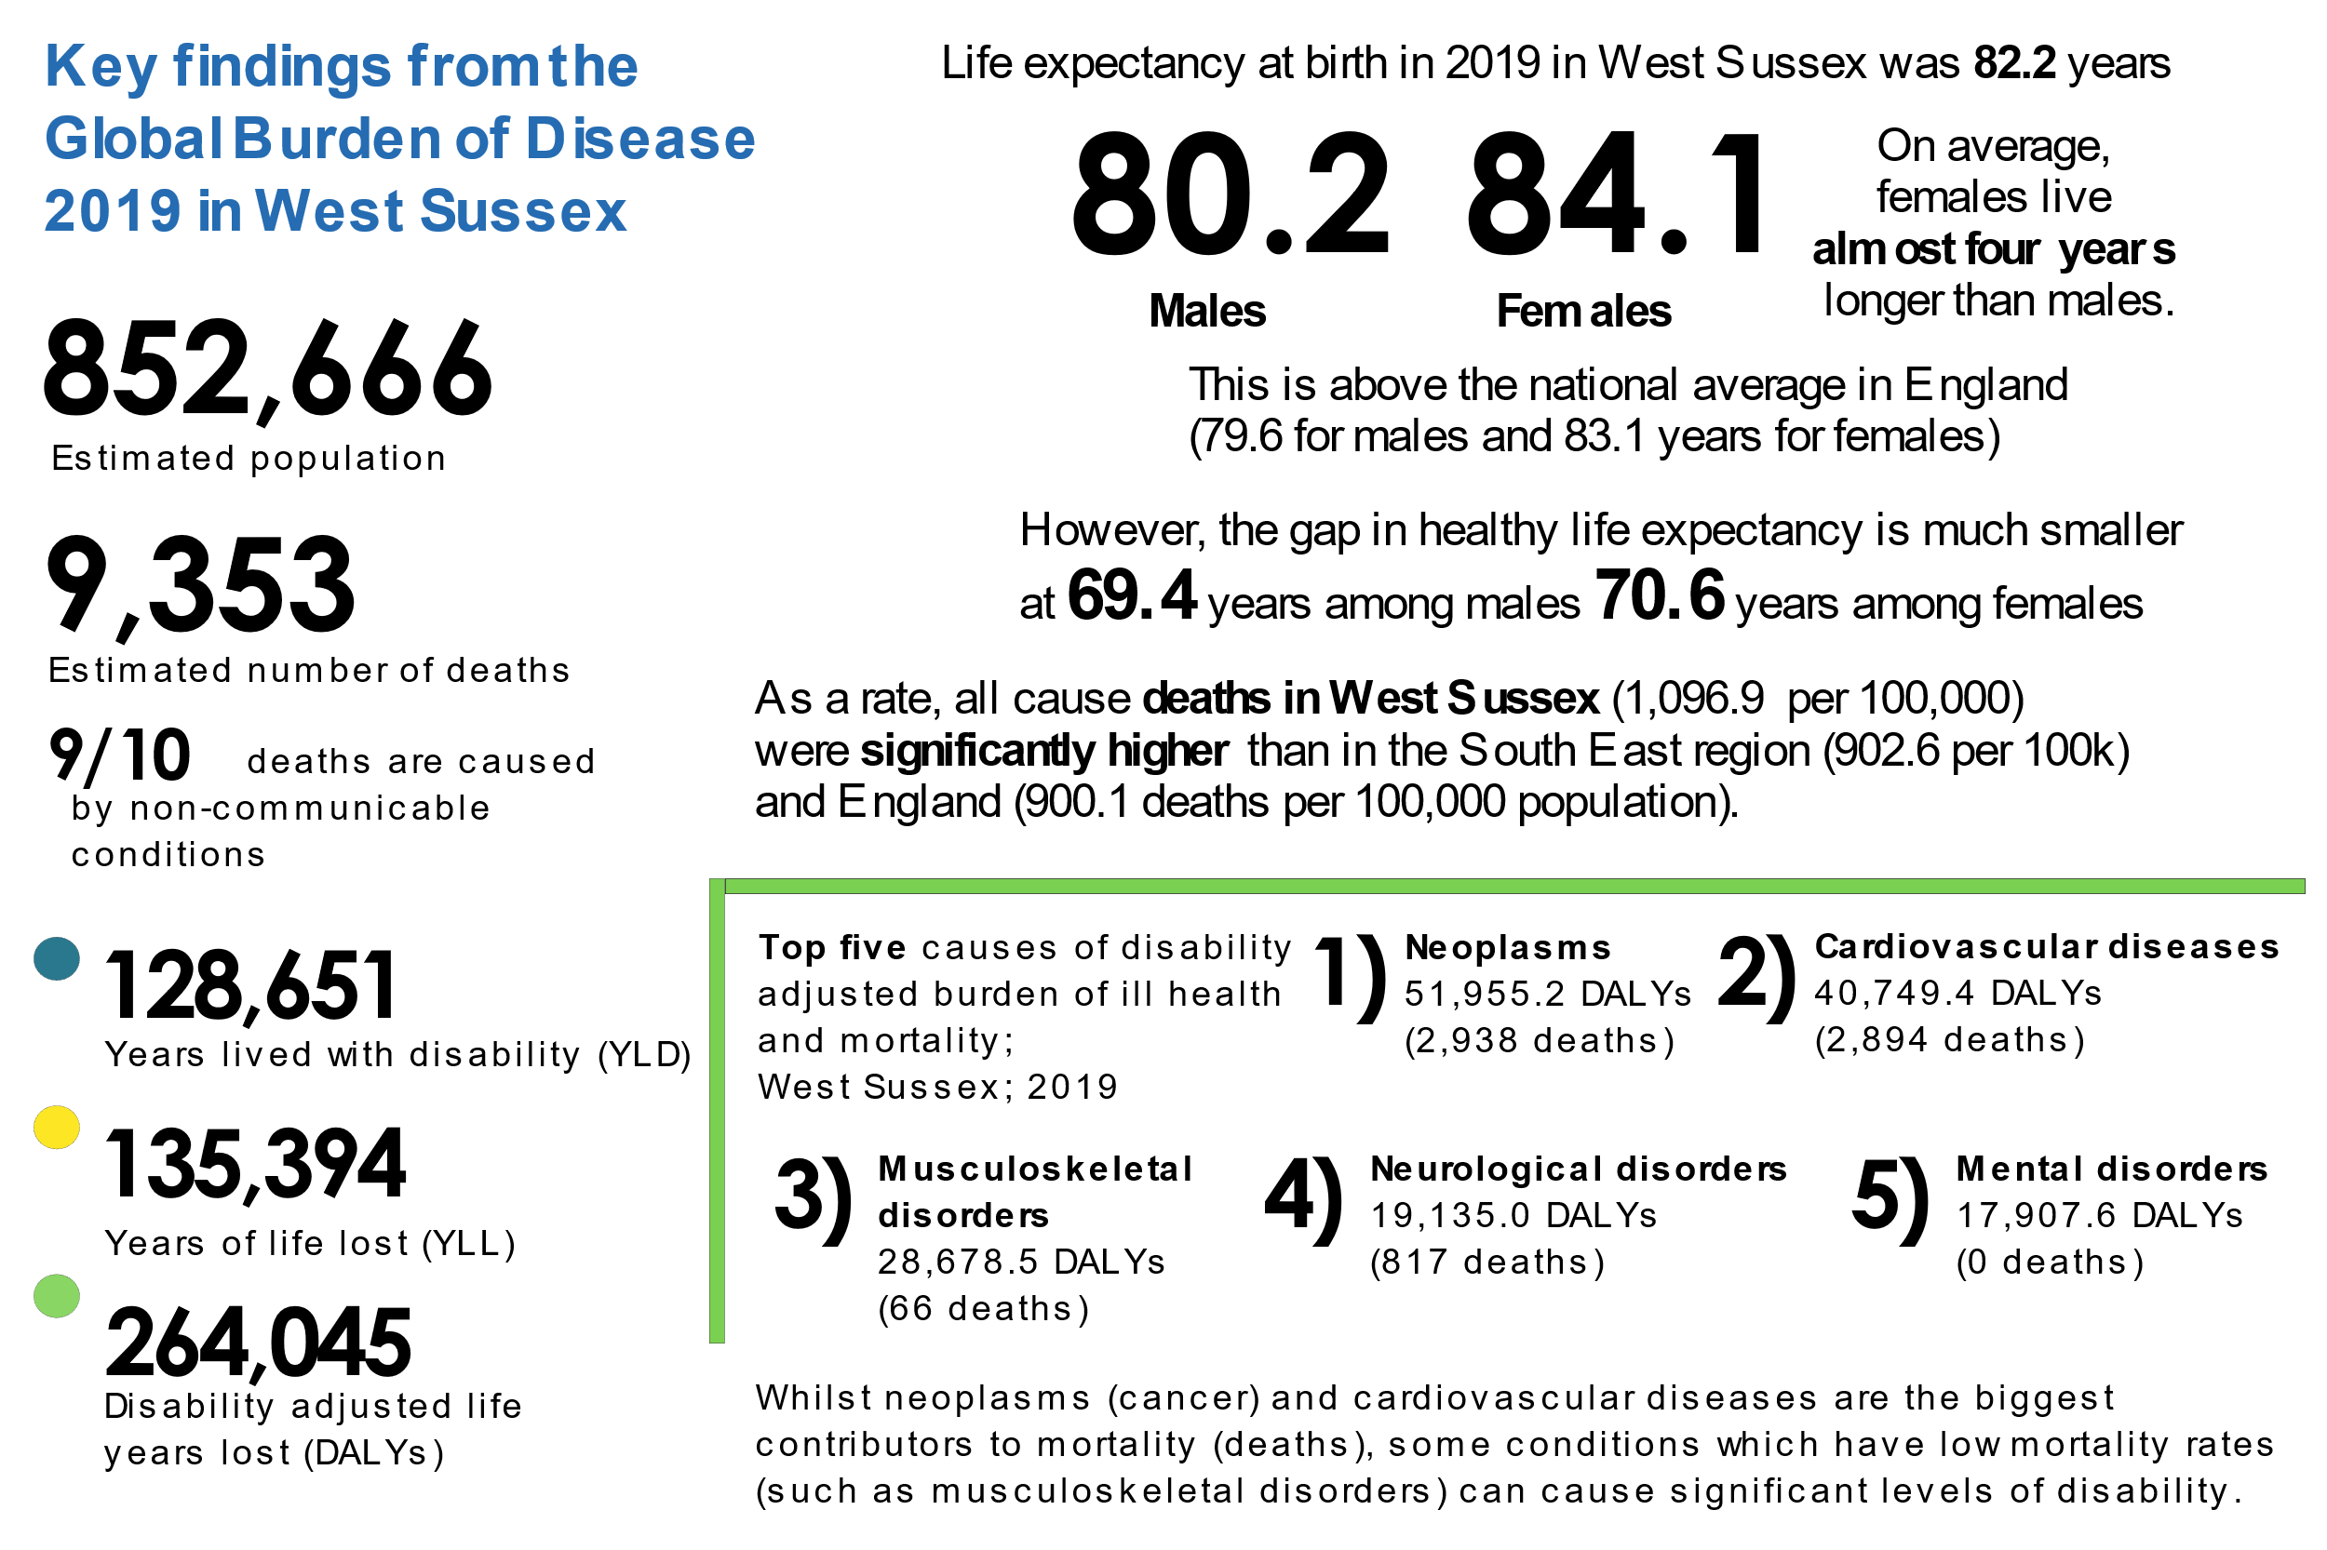

Figure 1.1 an overview of the burden of disease in West Sussex in 2019

Data are refreshed every two years and with each revision, data and methodological innovations are fed into models, annual estimates are comprised for 360 diseases and injuries and 85 risk factors.

In this analysis, which serves to present an overall picture of burden of disease in West Sussex, we aim to describe changes in life expectancy over time as well as explore the top causes of death for those living in West Sussex, comparing to regional and national estimates where possible. We also aim to describe alternative measures of the burden of disease.

Individual country profiles, as well as regional reports created by the IHME are available on the [http://www.healthdata.org](http://www.healthdata.org/) website. The profile for England can be found at <http://www.healthdata.org/united-kingdom-england> and the South East region can be found at http://www.healthdata.org/united-kingdom-england-south-east-england.

The time period covered in the latest GBD release is 2019 and is prior to the impact on the SARS-CoV-2 Coronavirus (COVID-19) global pandemic.

The COVID-19 pandemic will undoubtably alter the trends in ill health and mortality that have been observed in the population.

However, commissioners, policy makers, and other stakeholders, will need to understand the landscape of the burden of disease prior to the pandemic to understand the impact of it, as well as support the recovery. As soon as it is possible to incorporate the impact of COVID-19 on these estimates the report will be updated.

## Concepts and caveats

Whilst we explore the leading causes of death in West Sussex, and the relative changes in life expectancy, the burden of disease can be measured by more than just what kills us and the number of people who have died.

Figure 1.2 illustrates the different measures of the burden of ill health over the life course of a typical person. These are healthy (disease free) life years, years lived with disability (YLD), years of life lost (YLL) and disability adjusted life years lost (DALY).

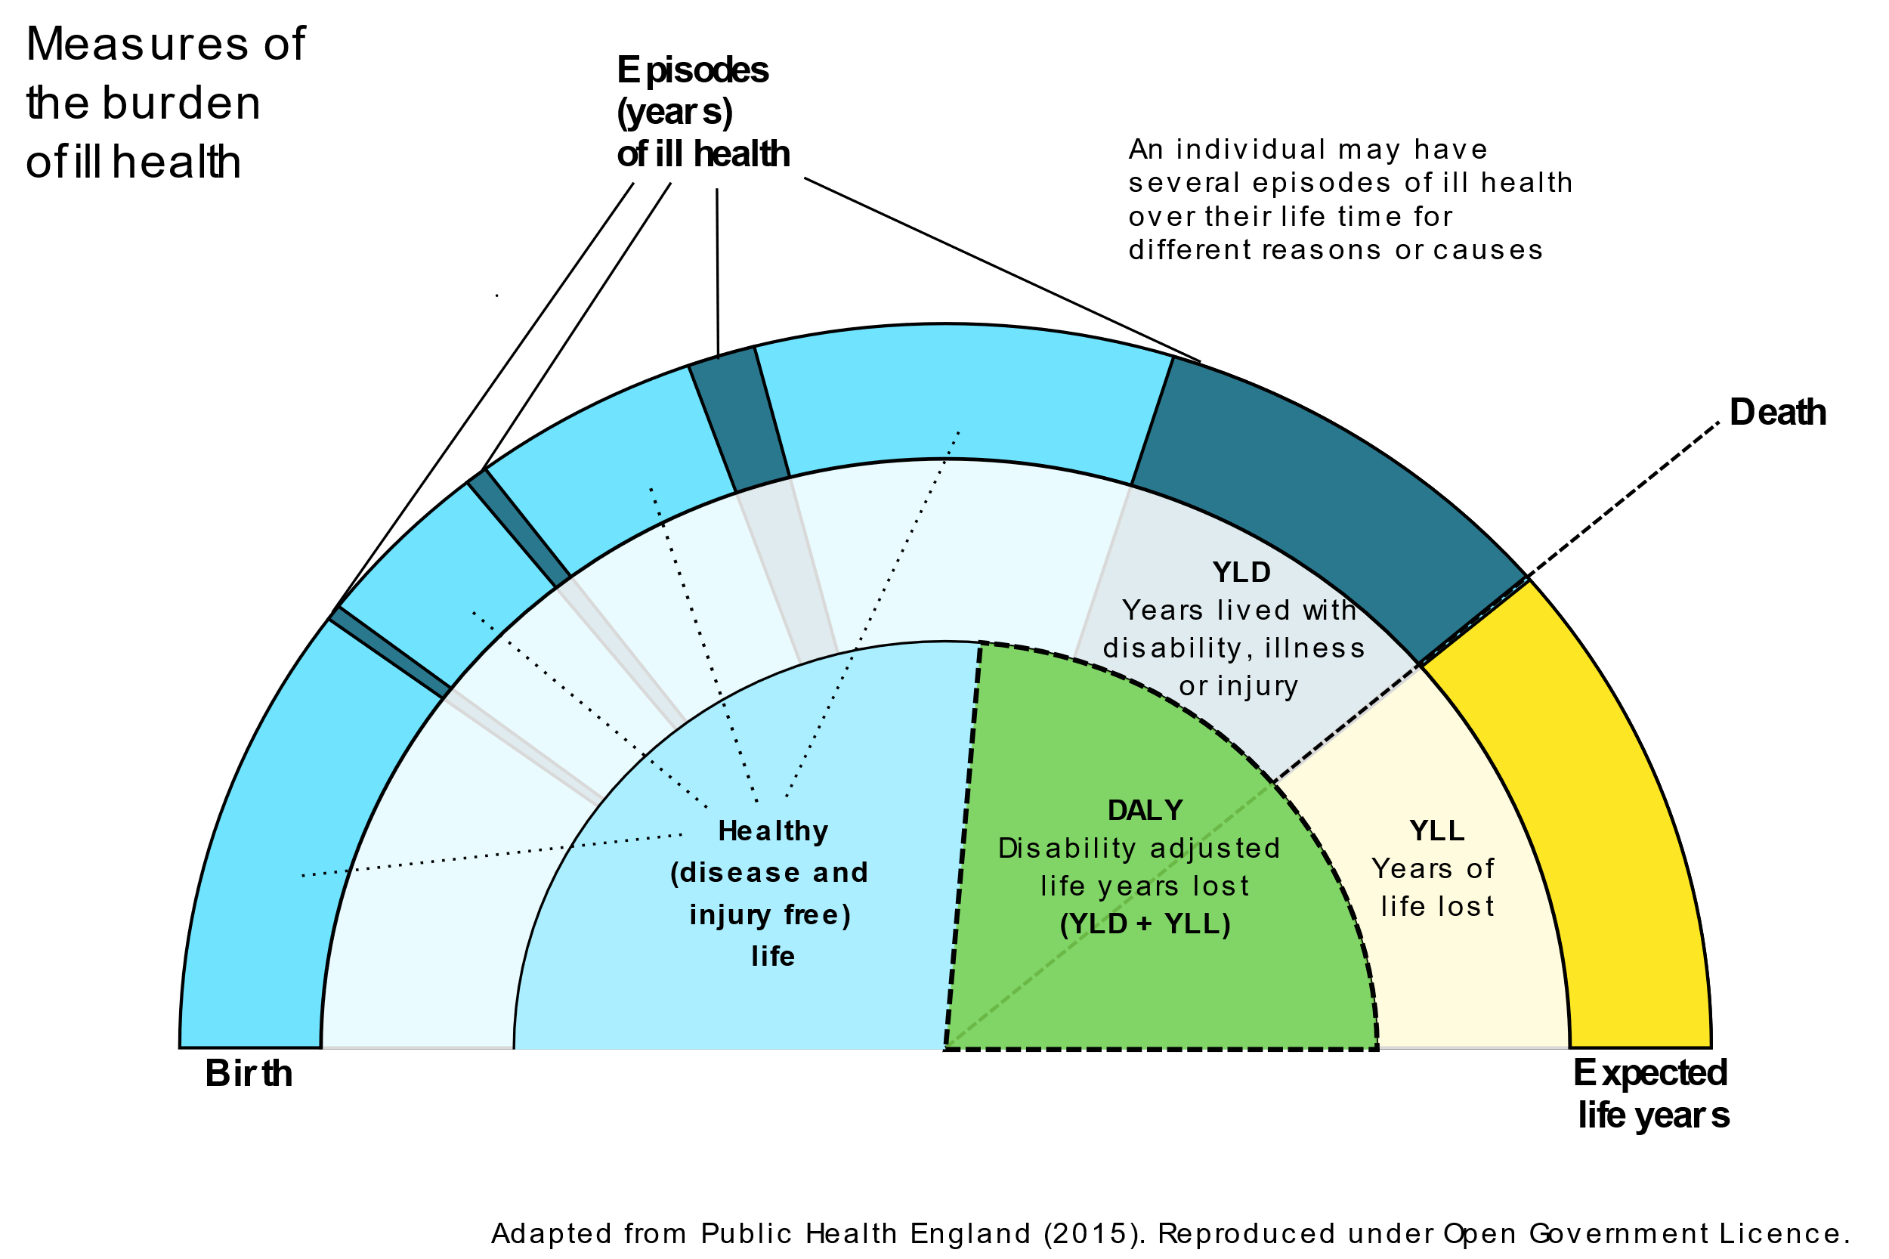

Figure 1.2. Concepts of the global burden of disease

In England, when a person dies, their death is certified and registered formally upon the issue of a medical certificate detailing the cause or causes of death; usually within five days of the death occurring.  
  
In some cases the cause of death is clear (for example accidents/injuries) but for others it may be much more complicated (for example among those with multiple long-term conditions). Cause-specific deaths (discussed later in this analyses) are estimated using statistical modelling and are adjusted to match the all-cause totals.

Years of life lost (YLLs) are calculated by subtracting the age at death from the longest possible life expectancy for a person at that age and sex. If the longest life expectancy for males in a given country is 75, and a male dies of cancer at 65, this would be 10 years of life lost due to cancer, if a female dies at the same age but the life expectancy for females is 85, this is 20 YLLs.

Years lived with disability (YLDs) are the number of years lived in less than ideal health. Some conditions such as influenza last for a few days, whereas epilepsy can last a lifetime. Disability weights reflecting the severity of each condition are developed using a variety of data sources including national surveys, the national cancer registration system, hospital episode statistics and published research studies.

Disability Adjusted Life Years (DALYs) are the sum of years of life lost and years lived with disability. This is the best measure to consider the overall impact of a specific cause or group of causes on a population.

The green section (the DALY) is a useful measure because it also allows the comparison of acute conditions such as stroke or heart attacks with conditions like diabetes or circulatory diseases with conditions such as musculoskeletal disorders which may not ordinarily cause premature death but none the less reduce the quality of someone’s life.

DALYs use disability weights (0 = perfect health and 1 = death) which are generated through consultations with clinicians and other experts. This helps to account for those conditions which can be well managed.

As such, a DALY represents the amount of time in sub-optimal health and our goal in public health is to reduce the DALY values where possible and improve the chances of individuals spending more of their lives in good quality healthy states.

### What you should know

There are several caveats and limitations you should consider when using these estimates

* The GBD ethos is that an uncertain estimate, even when data are sparse or not available, is preferable to no estimate at all. As a result, you should consider that there is a margin of error when interpreting these results as they are simply estimates or 'best guesses'.
* Estimates from the GBD do not compare directly to reported statistics within England (where these are available) as all estimates are constructed using the GBD methodology. Note that figures are rounded to the nearest whole number, and percentages are rounded to the nearest single decimal point. This is to make interpretation of the findings easier to follow but it can mean that some values show as zero when they have a value between 0 and 0.5.
* A change in rank does not necessarily mean that a metric for a cause has got better/worse.
* The GBD diseases/conditions and risks are split and aggregated into hierarchical levels. The cause list is mutually exclusive and collectively exhaustive at every level of aggregation; causes not individually specified are captured in residual categories, such as 'other intestinal infectious diseases'.

**Condition hierarchy**

The global burden of disease conditions can be grouped at four levels of hierarchy which are useful depending on the goal of any analysis. We use the level two groupings for most of the analyses set out in this report. The figure below shows the top two condition hierarchies.

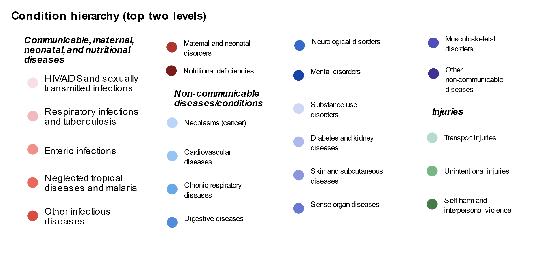

Figure 1.3. Level two condition groups

At the highest level there are three broad cause groups: communicable, non-communicable, and injuries. he next (level two) groupings contain 22 cause groups, which can then be broken down into 169 level three conditions, and at the most granular level (level four) there are 364 specific conditions. We have tried to use three colours (red, blue, and green) to distinguish the level two groups throughout the figures used in this report.

## Life expectancy

Life expectancy has increased in the last 20 years, from 77.7 years in 1999 to 82.2 years in 2019 (80.1 years to 84.1 years among females and from 74.9 years to 80.2 years among males). This shows a gap of almost four years between males and females in West Sussex in the latest estimated life expectancy at birth. Figure 2.1 shows the gradual increase in both life expectancy at birth and healthy-life expectancy for West Sussex between 1990 and 2019 by sex. Females are on the top blue line, and males are in orange.

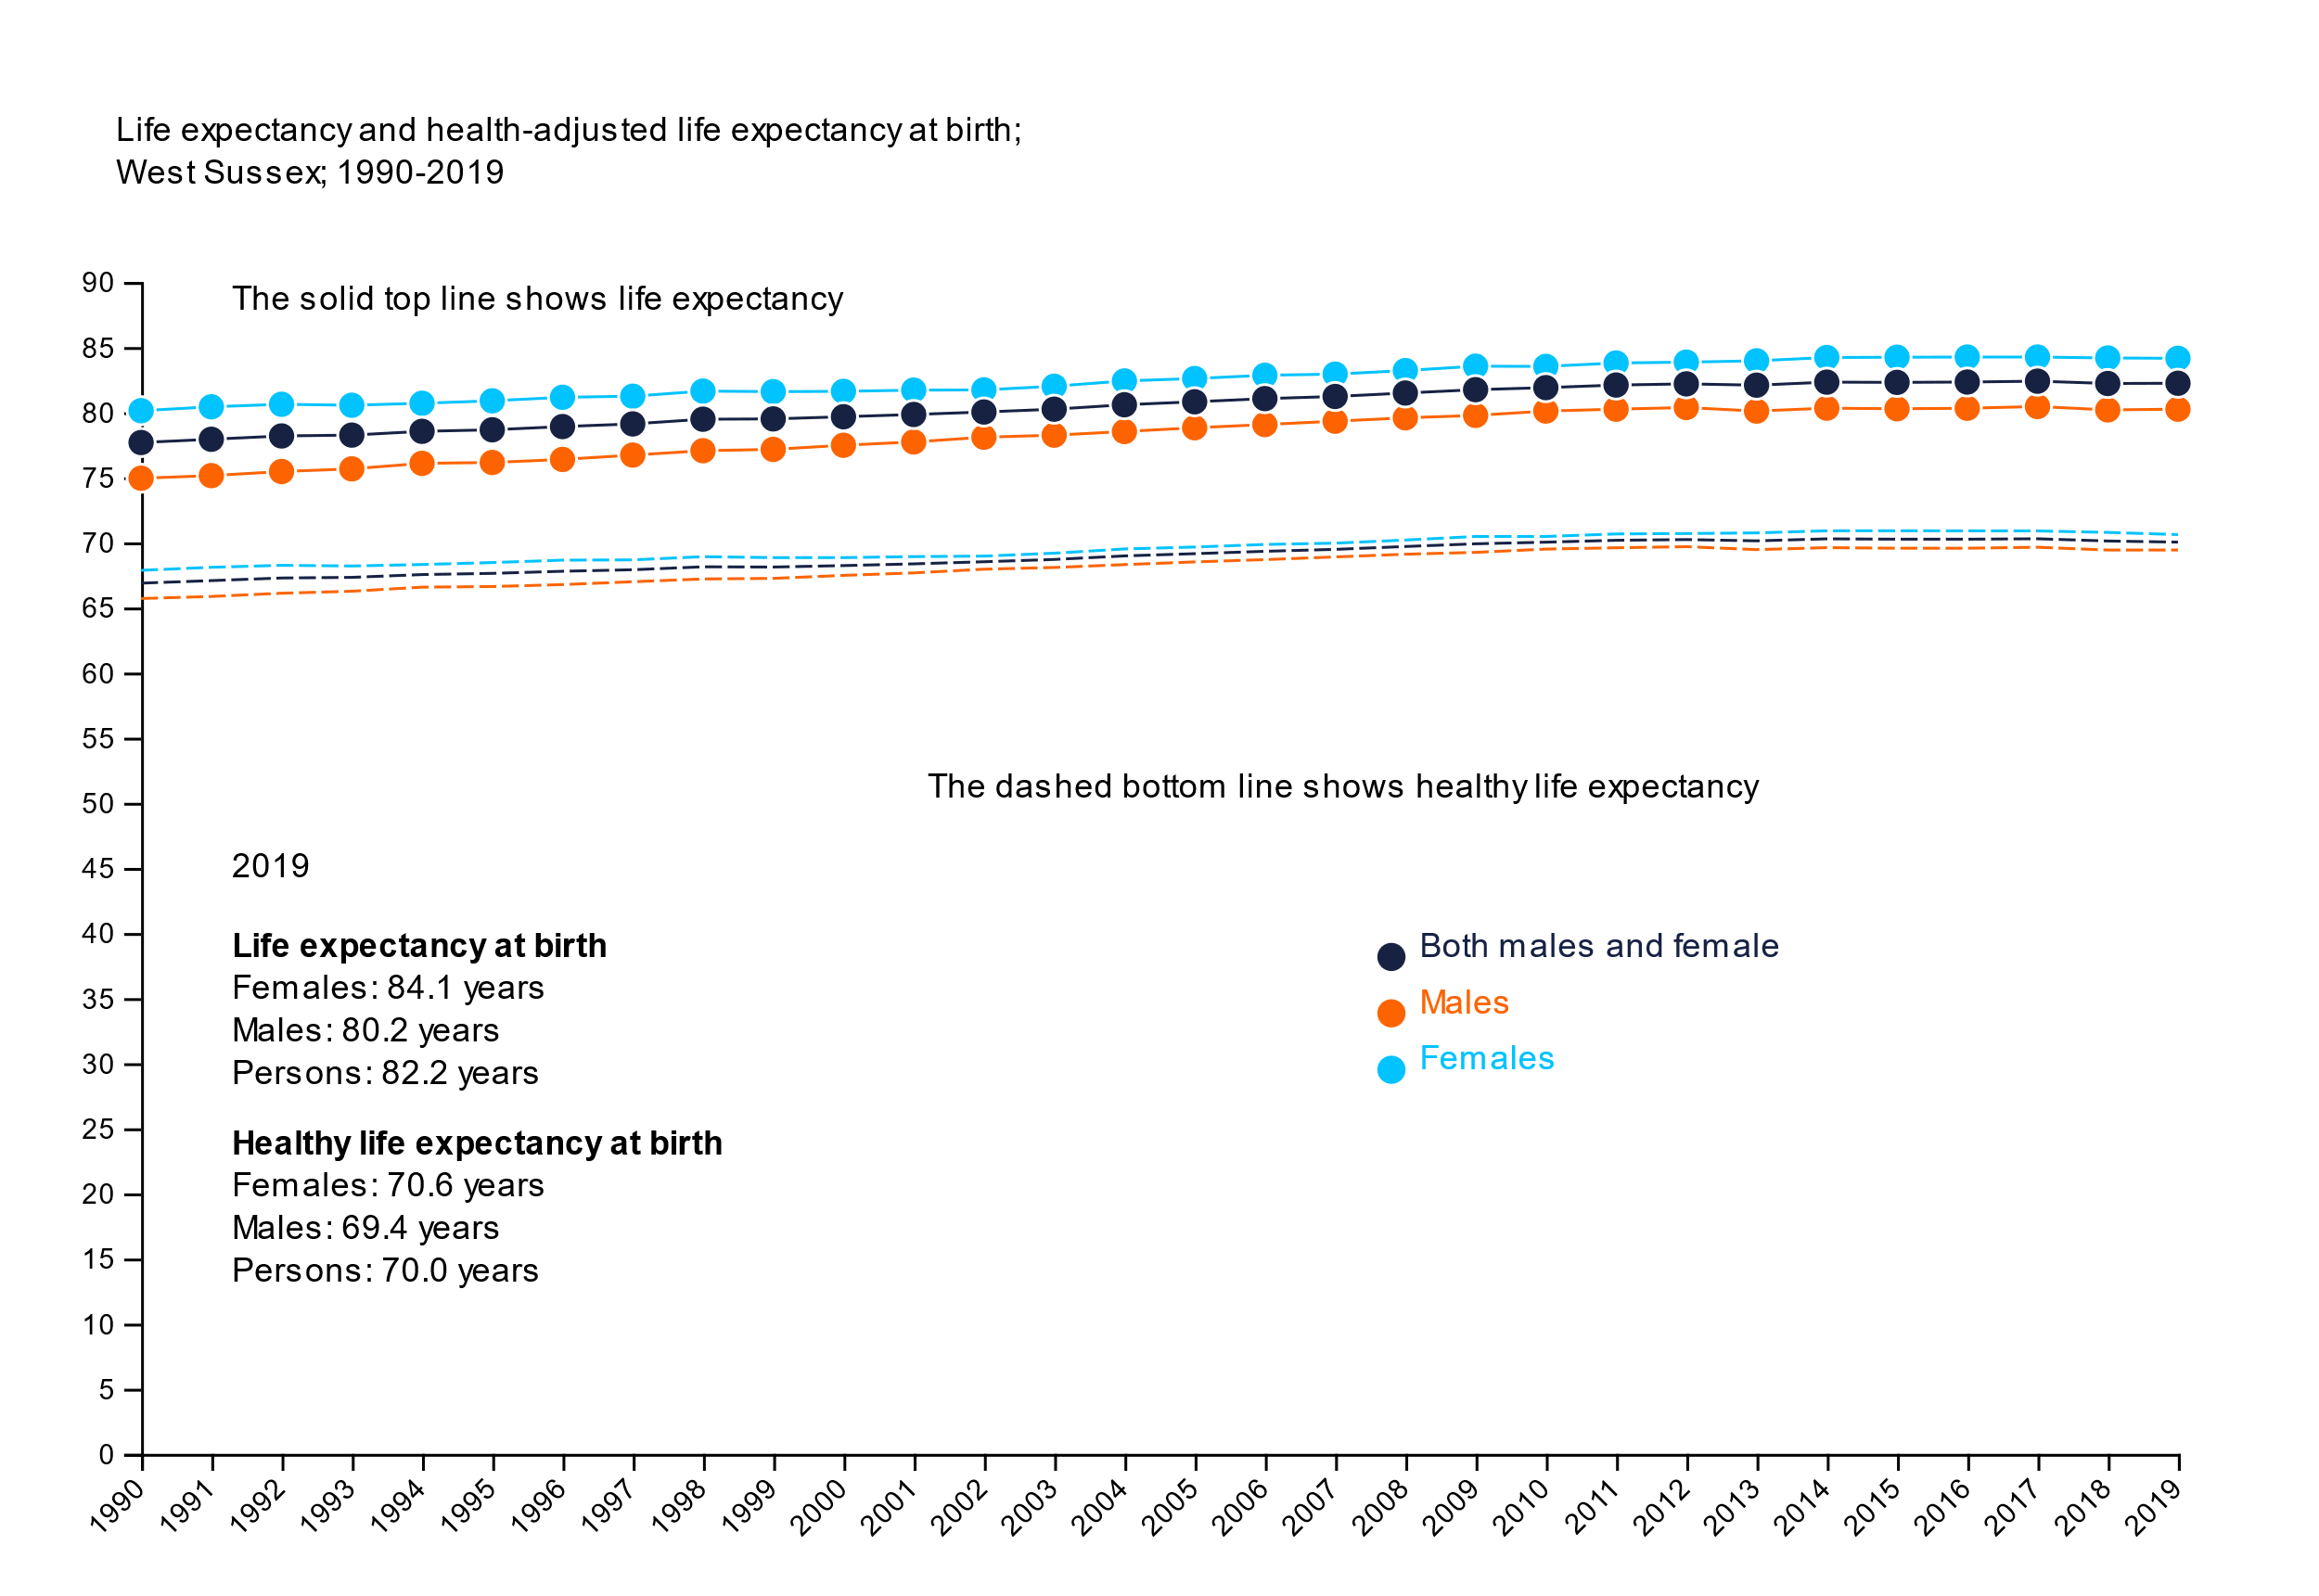

Figure 2.1. Life expectancy and health-adjusted life expectancy at birth; West Sussex; 1990-2019

Healthy life expectancy has also increased since 1999 from 66.9 years overall (67.9 years and 65.7 years, for females and males respectively) to 70.0 years in 2019 (70.6 years and 69.4 years, for females and males respectively). The gain in healthy life expectancy has not been as high (in terms of percentage increase or actual years) compared to gains in overall life expectancy, and like overall life expectancy, male healthy life expectancy trails behind females although the gap is much smaller at just over one year’s difference.

Whilst females may live longer lives than males, in West Sussex and nationally, females tend to spend more of their lives living with disability or in 'sub-optimal' health, compared to males.

Indeed, the modelled estimates suggest that, on average, a female born in 2019 can expect to live 3.9 years longer overall compared to males. However, they can expect to live around 13.5 years (or 16.1% of their lifetime) in sub-optimal health whilst males can expect to spend 10.8 years (or 13.5% of their lifetime) with the burden of ill health.

## Causes of death

In 2019, there were estimated to be 9,353 deaths among those who live in West Sussex. As a rate per 100,000 population (a way to compare different areas), West Sussex (with a rate of 1,097 deaths per 100,000 people) had significantly higher mortality than in the South East region (903 deaths per 100,000) and England overall (900 deaths per 100,000 people). Roughly half of the deaths in the county in 2019 were amongst males (4,586 deaths, 49% of all deaths), with 4,767 deaths amongst females. The figures below show the top 10 causes of deaths in West Sussex, in 2019. These are the 'level two' cause groups.

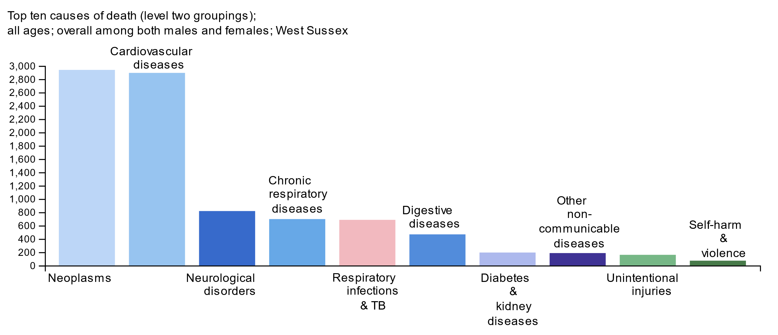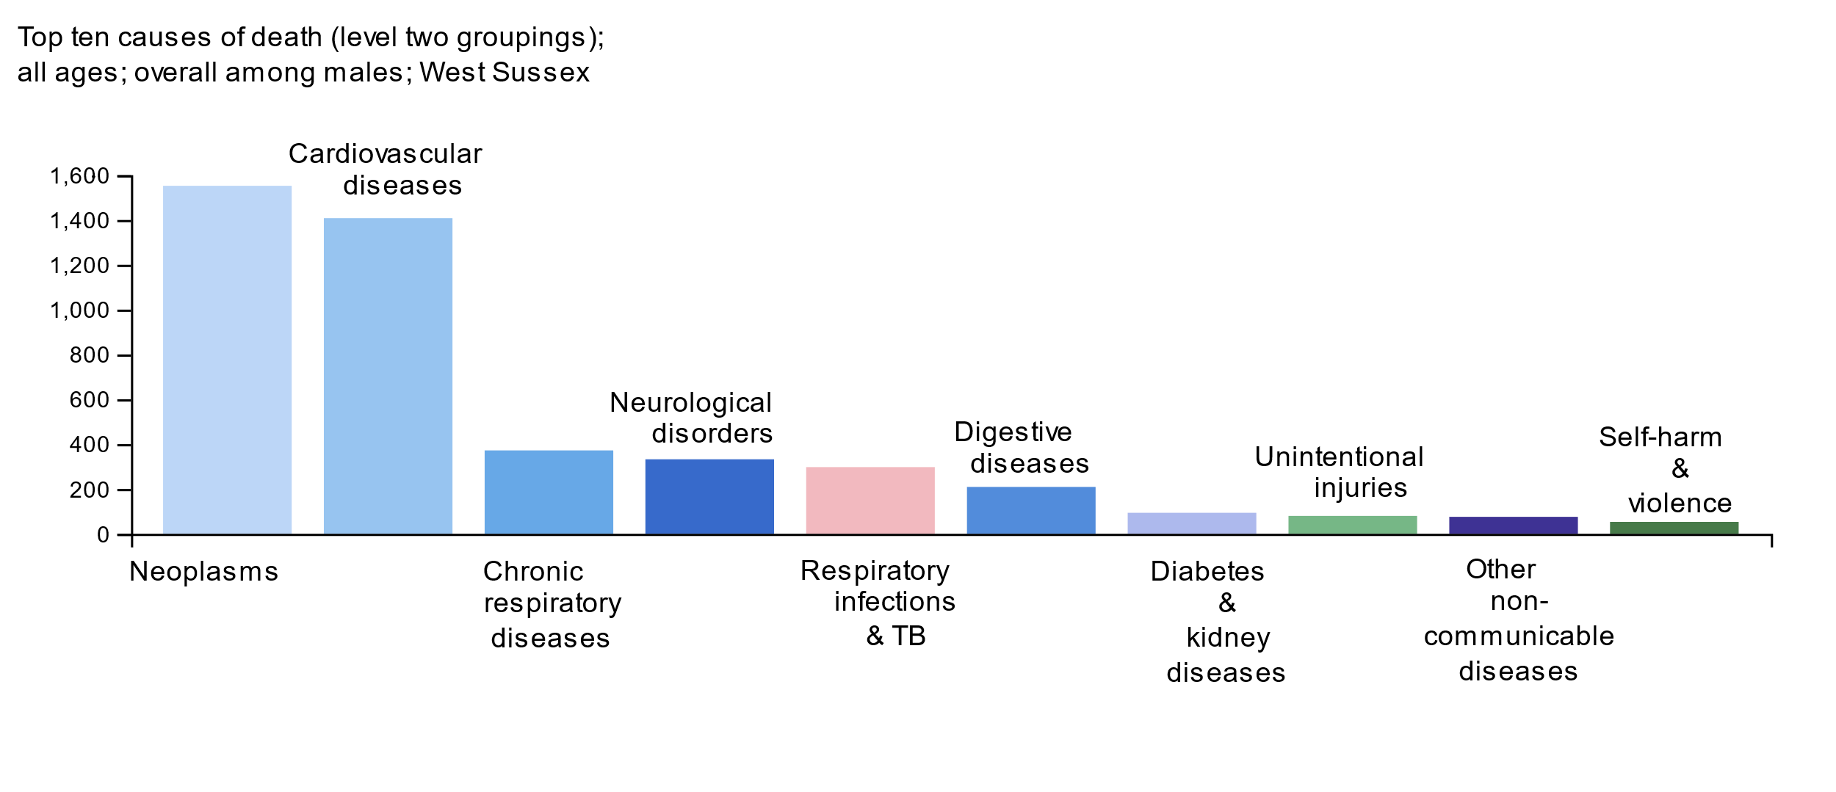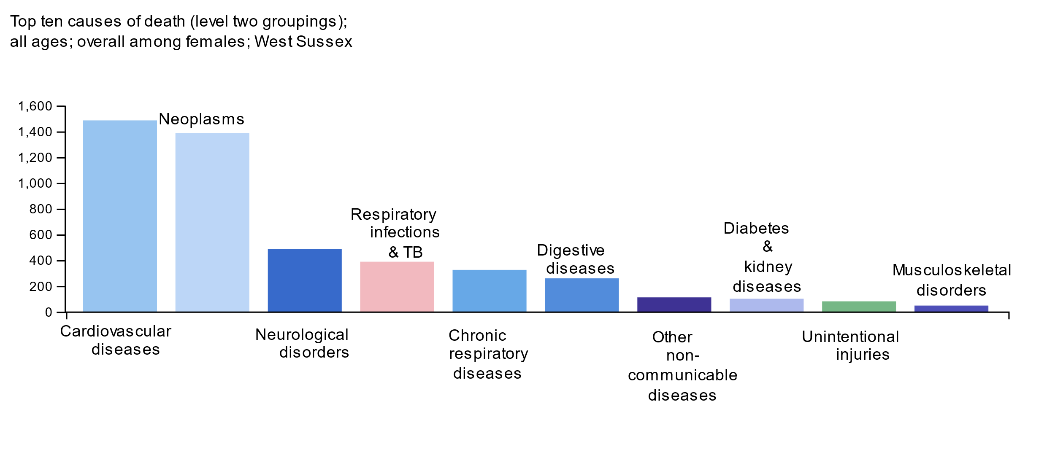

Figure 3.1. Top ten causes of death (level two groupings); West Sussex; 2019; all ages

In 2019, almost 90% of deaths (8,342 deaths) in West Sussex were caused by non-communicable diseases (these are coloured blue/purple in the figure). Communicable, maternal, neonatal and nutritional diseases (coloured red on the figure) accounted for 8% of deaths (741 deaths) and the majority of these are respiratory infections. Injuries caused 3% (270 deaths).

In West Sussex, the two largest cases of death accounted for nearly two thirds of deaths. These were neoplasms (cancers) estimated to cause 2,938 deaths and cardiovascular diseases (such as heart attacks, strokes, atrial fibrillation and aortic aneurysms) accounting for 2,938 deaths.

There are also differences in the top ten causes of death for males and females. Whilst the top two causes are the same for males and females, the third biggest cause of death for males was chronic respiratory diseases (such as chronic obstructive pulmonary disease (COPD) and other lung conditions). For females, the third largest cause of death in West Sussex was neurological disorders such as dementia, motor neurone disease, and multiple sclerosis.

Self-harm was the 10th biggest level 2 cause of death overall in West Sussex (72 deaths, around 1% of all deaths in the county) and three quarters of those self-harm and interpersonal violence deaths were among males (53 deaths). For females, however, self-harm does not appear in the top ten level 2 causes of death and is replaced by musculoskeletal disorders as having a greater impact on mortality in West Sussex estimated to be attributable to 48 deaths in 2019 among females. The 48 musculoskeletal deaths amongst females represent almost three quarters of musculoskeletal deaths overall.

## Beyond deaths

The table below shows the top ten level two causes of ill health for 2019 in West Sussex, with four columns representing the four measures of burden (deaths, YLLs, YLDs and DALYs).

Table 4.1. Top ten causes of mortality and ill health; West Sussex; 2019; all ages

| **Deaths** | **YLLs (Years of lost life)** | **YLDS (Years lived with disability)** | **DALYs (Disability-adjusted life years lost)** |
| --- | --- | --- | --- |
| 1) Neoplasms (2,938) | 1) Neoplasms (48,961) | 1) Musculoskeletal disorders (27,820) | 1) Neoplasms (51,955) |
| 2) Cardiovascular  diseases (2,894) | 2) Cardiovascular diseases (35,984) | 2) Mental disorders (17,900) | 2) Cardiovascular diseases (40,749) |
| 3) Neurological  disorders (817) | 3) Neurological disorders (9,408) | 3) Other non-communicable diseases (12,339) | 3) Musculoskeletal disorders (28,678) |
| 4) Chronic respiratory diseases (697) | 4) Chronic respiratory diseases (9,179) | 4) Neurological disorders (9,727) | 4) Neurological disorders (19,135) |
| 5) Respiratory infections and tuberculosis (685) | 5) Digestive diseases (7,377) | 5) Diabetes and kidney diseases (8,779) | 5) Mental disorders (17,908) |
| 6) Digestive diseases (467) | 6) Respiratory infections and tuberculosis (7,033) | 6) Unintentional injuries (8,406) | 6) Chronic respiratory diseases (16,998) |
| 7) Diabetes and kidney diseases (194) | 7) Other non-communicable diseases (3,357) | 7) Sense organ diseases (7,847) | 7) Other non-communicable diseases (15,695) |
| 8) Other non-communicable diseases (186) | 8) Self-harm and interpersonal violence (2,859) | 8) Chronic respiratory diseases (7,819) | 8) Digestive diseases (11,745) |
| 9) Unintentional injuries (160) | 9) Unintentional injuries (2,388) | 9) Skin and subcutaneous diseases (5,326) | 9) Diabetes and kidney diseases (11,123) |
| 10) Self-harm and interpersonal violence (72) | 10) Diabetes and kidney diseases (2,345) | 10) Substance use disorders (4,978) | 10) Unintentional injuries (10,795) |

There are stark differences in ranks of conditions depending on the measure you use. For some conditions, the majority of deaths occur at a relatively old age and as such the YLLs (the premature life years lost) may be fairly low, particularly if the condition can be managed well for a number of years, whilst YLDs (years lived with disability) may be relatively high.

An example of this is the mental disorders group of conditions (which includes schizophrenia, depressive disorder, anxiety, and eating disorders as well as autism spectrum disorder). Mental disorders ranked 20th out of 22 conditions for deaths and YLLs, yet this group of conditions ranks 2nd for years lived with disability indicating that mental disorders impose a substantial burden of disability on the population with those who have these conditions expected to live a large part of their lifetime in 'sub-optimal health'. When using the overall burden, as measured by DALYs, mental disorders ranks 5th out of 22.

Another example is musculoskeletal conditions which account for very few deaths (66 deaths, or less than 1% of deaths in West Sussex in 2019) but were estimated to be responsible for almost one in four years of life lived with disability (27,820, 22% of YLDs) in West Sussex in 2019.

Other conditions have low years lived with disability and high premature years of life lost. The respiratory infections and tuberculosis disease group includes lower and upper respiratory infections, Otitis media (inflammatory diseases of the middle ear) and Tuberculosis. Based on the findings of the GBD study, people might expect to contract these illnesses early in their lifetimes and suffer for a limited time before dying as a result of the condition.

Remember, the overall burden as measured by DALYs is the sum of YLLs and YLDs and this does not take into account which aspect (premature death or long life living with the burden of disease) contributes more.

Based on DALYs, the condition group sense organ diseases (including blindness and visual impairment caused by Glaucoma, Cataract, and Macular degeneration as well as hearing loss) has the equivalent burden (7,847 DALYs) to respiratory infections and tuberculosis (7,973 DALYs).

An obvious limitation of using DALYs is that the level of disability experienced by individuals will vary from minimal interruption to significant disruption of daily life and dependence on others for care.

As a result, it is recommended to consider all measures of burden for a given condition to understand how it impacts the population.

## Exploring the detail of burden

The level two causes of ill health can be further divided into 169 'level three' causes (and in some cases can be broken down even further). In this section we visualise the burden of different causes of ill health and death for West Sussex residents (both males and females) in 2019. There are four figures (one for each of the burden measures). Each circle on a figure represents a level three condition. The size of the circle denotes the value (on figure 5.1. this is the number of deaths, but for other measures it is the number of years) and this should help to visualise the relative contribution of each condition to the burden of ill health.

As with other figures in the report, you can view an interactive version of this figure by going to the <https://wsx-gbd-2019.netlify.app/> page.

The circles are split into six groups; along the top from left to right, you can see neoplasms (cancer), chronic respiratory diseases and musculoskeletal disorders. Along the bottom are cardiovascular diseases, neurological disorders and lastly the remaining condition groups.

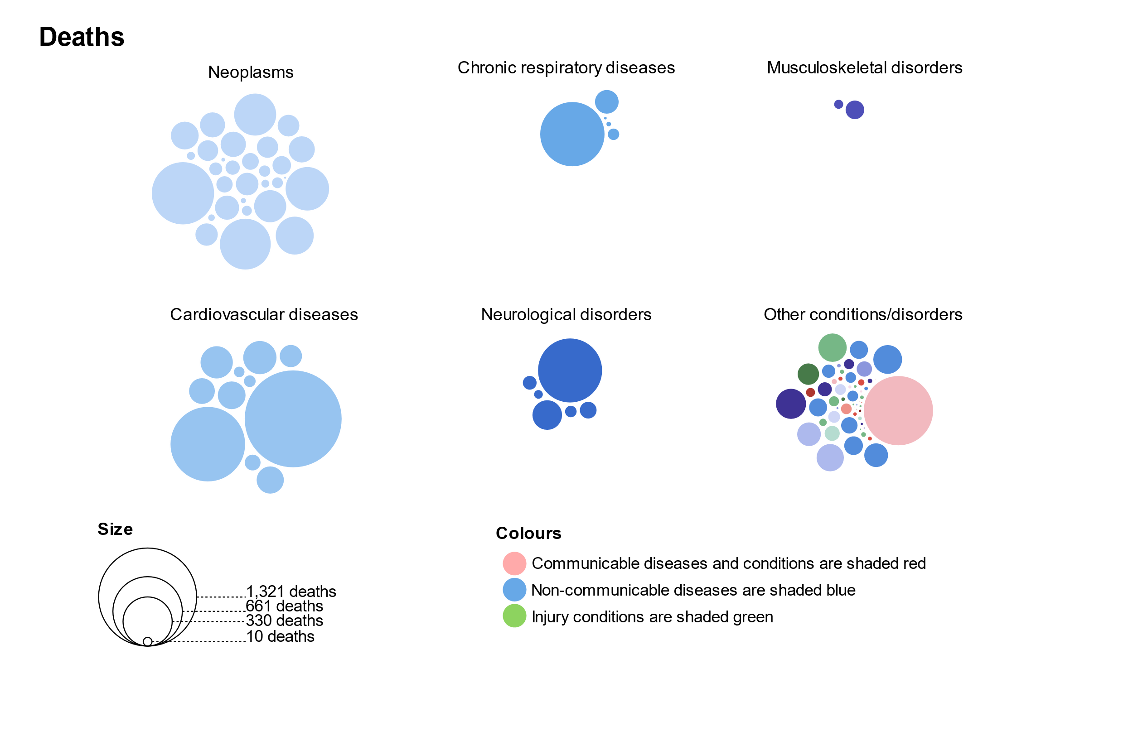

Figure 5.1. Estimated number of deaths in West Sussex; 2019

We have used colour to try to distinguish the different condition groups. The red circles denote communicable diseases, blue for non-communicable diseases and green for injuries. The circles have also been grouped into the top level two condition groups contributing the most burden. You can see the specific colours used for each level two group at the top of this report.

It is clear that cancer and cardiovascular diseases overall are the biggest causes of mortality. Within these groups it is ischaemic heart disease and stroke which are the two biggest level three causes in the cardiovascular group and lung and colon cancers are the biggest causes of death in the neoplasm group. Lower respiratory infections, COPD and dementia are the three leading causes of death outside of cancer and cardiovascular disease.

The pattern is similar for deaths and in years of life lost as a measure of premature mortality (overleaf).

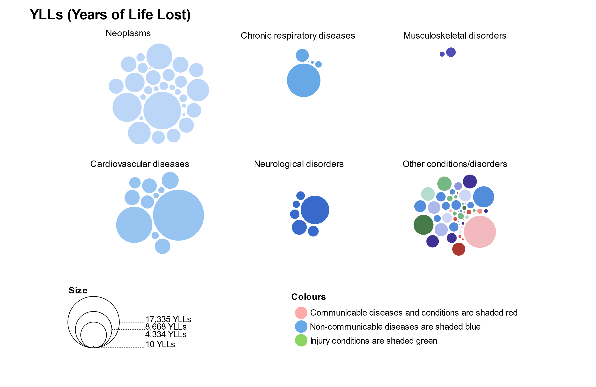

Figure 5.2. Estimated number of years of life lost in West Sussex; 2019

**Good to remember**

Years of life lost (YLLs) are calculated by subtracting the age at death from the longest possible life expectancy for a person at that age and sex. If the longest life expectancy for males in a given country is 75, and a male dies of cancer at 65, this would be 10 years of life lost due to cancer, if a female dies at the same age but the life expectancy for females is 85, this is 20 YLLs.

Years lived with disability (YLDs) are the number of years lived in less than ideal health. Some conditions such as influenza last for a few days, whereas epilepsy can last a lifetime. Disability weights reflecting the severity of each condition are developed using a variety of data sources including national surveys, the national cancer registration system, hospital episode statistics and published research studies.

Disability Adjusted Life Years (DALYs) are the sum of years of life lost and years lived with disability. This is the best measure to consider the overall impact of a specific cause or group of causes on a population.

Musculoskeletal disorders contribute relatively little to mortality as discussed in the previous section. However, by viewing years lived with disability it is clear that from figure 5.3. overleaf, that low back pain, neck pain and osteoarthritis are much greater contributors to the burden of disease and dwarf those conditions which tend to be bigger killers.

Depressive and anxiety disorders, falls, headaches and migraines, diabetes, and hearing loss are all conditions which may not always cause death but nonetheless contribute substantially to the disabilities and sub-optimal health experienced by individuals in West Sussex.

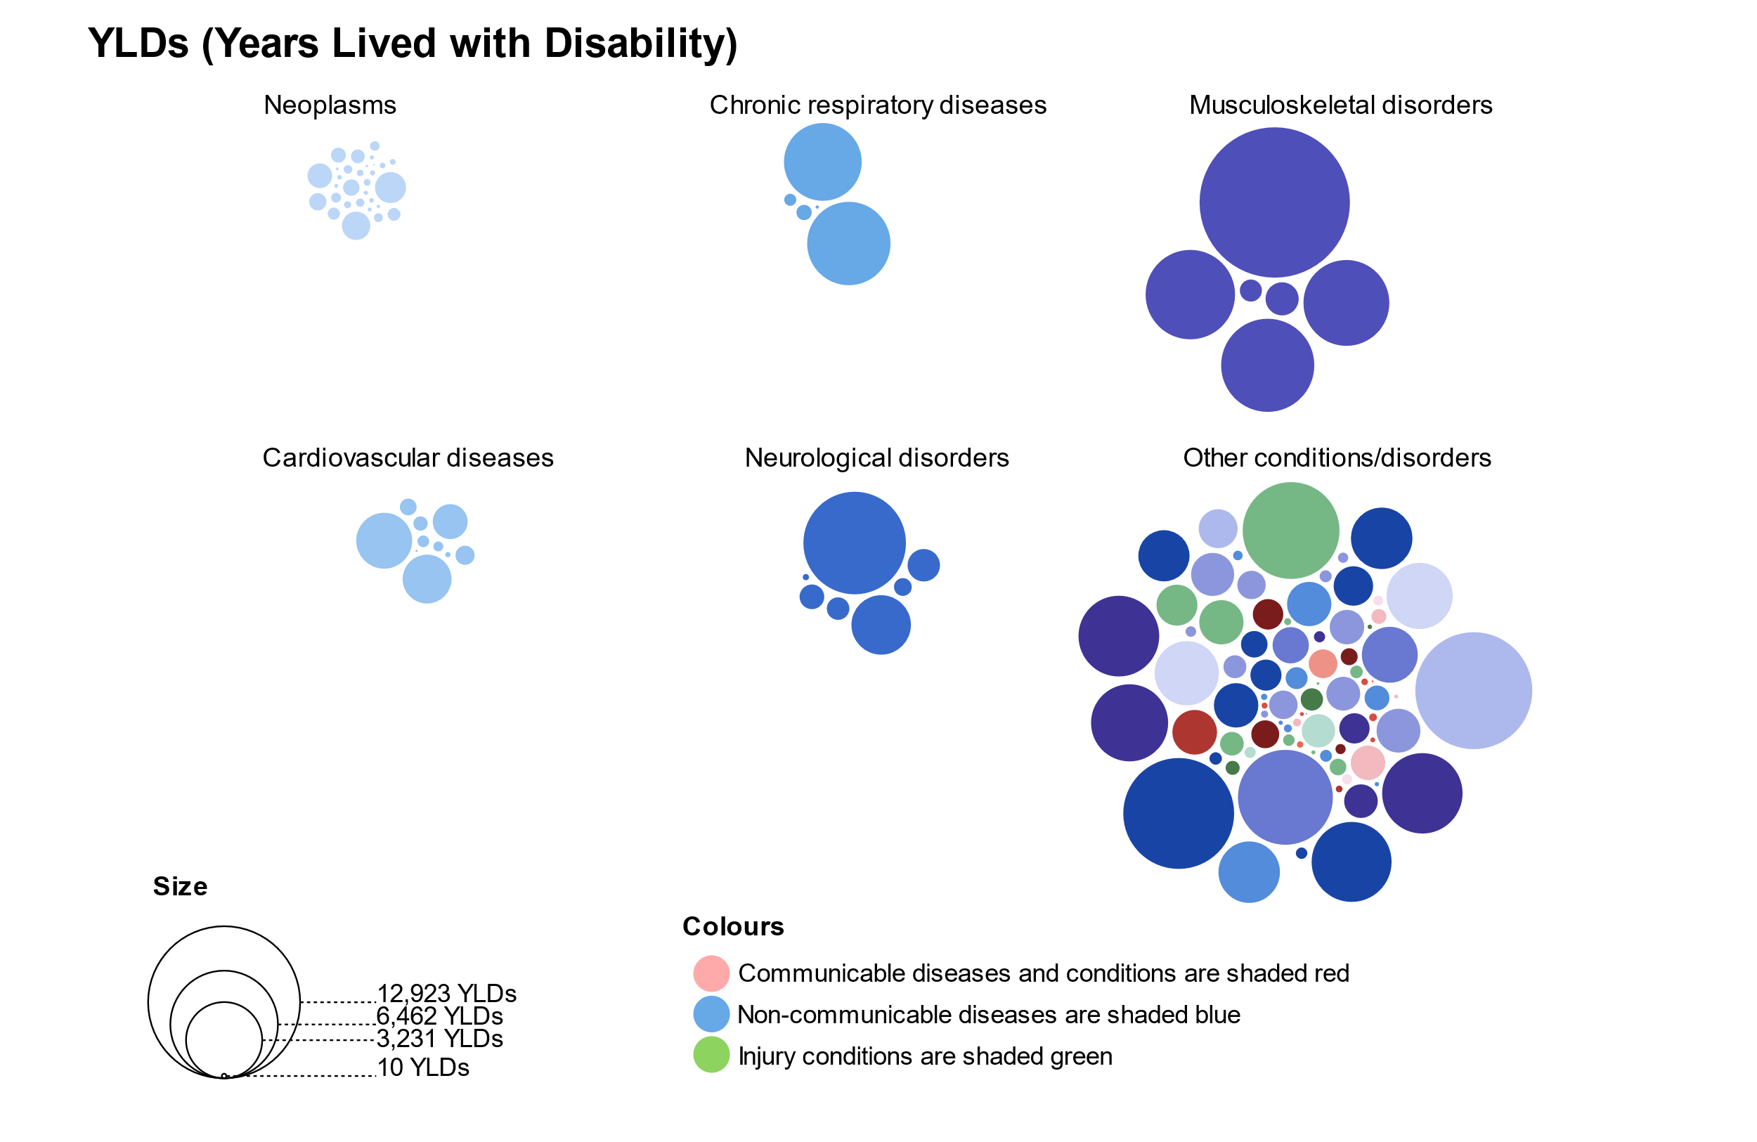

Figure 5.3. Estimated number of years lived with disability in West Sussex; 2019

When combining estimates of premature mortality and disability adjusted life years, individual level three conditions stick out across the condition groups. There are: ischaemic heart disease, low back pain, COPD, stroke, lung cancers, and diabetes.

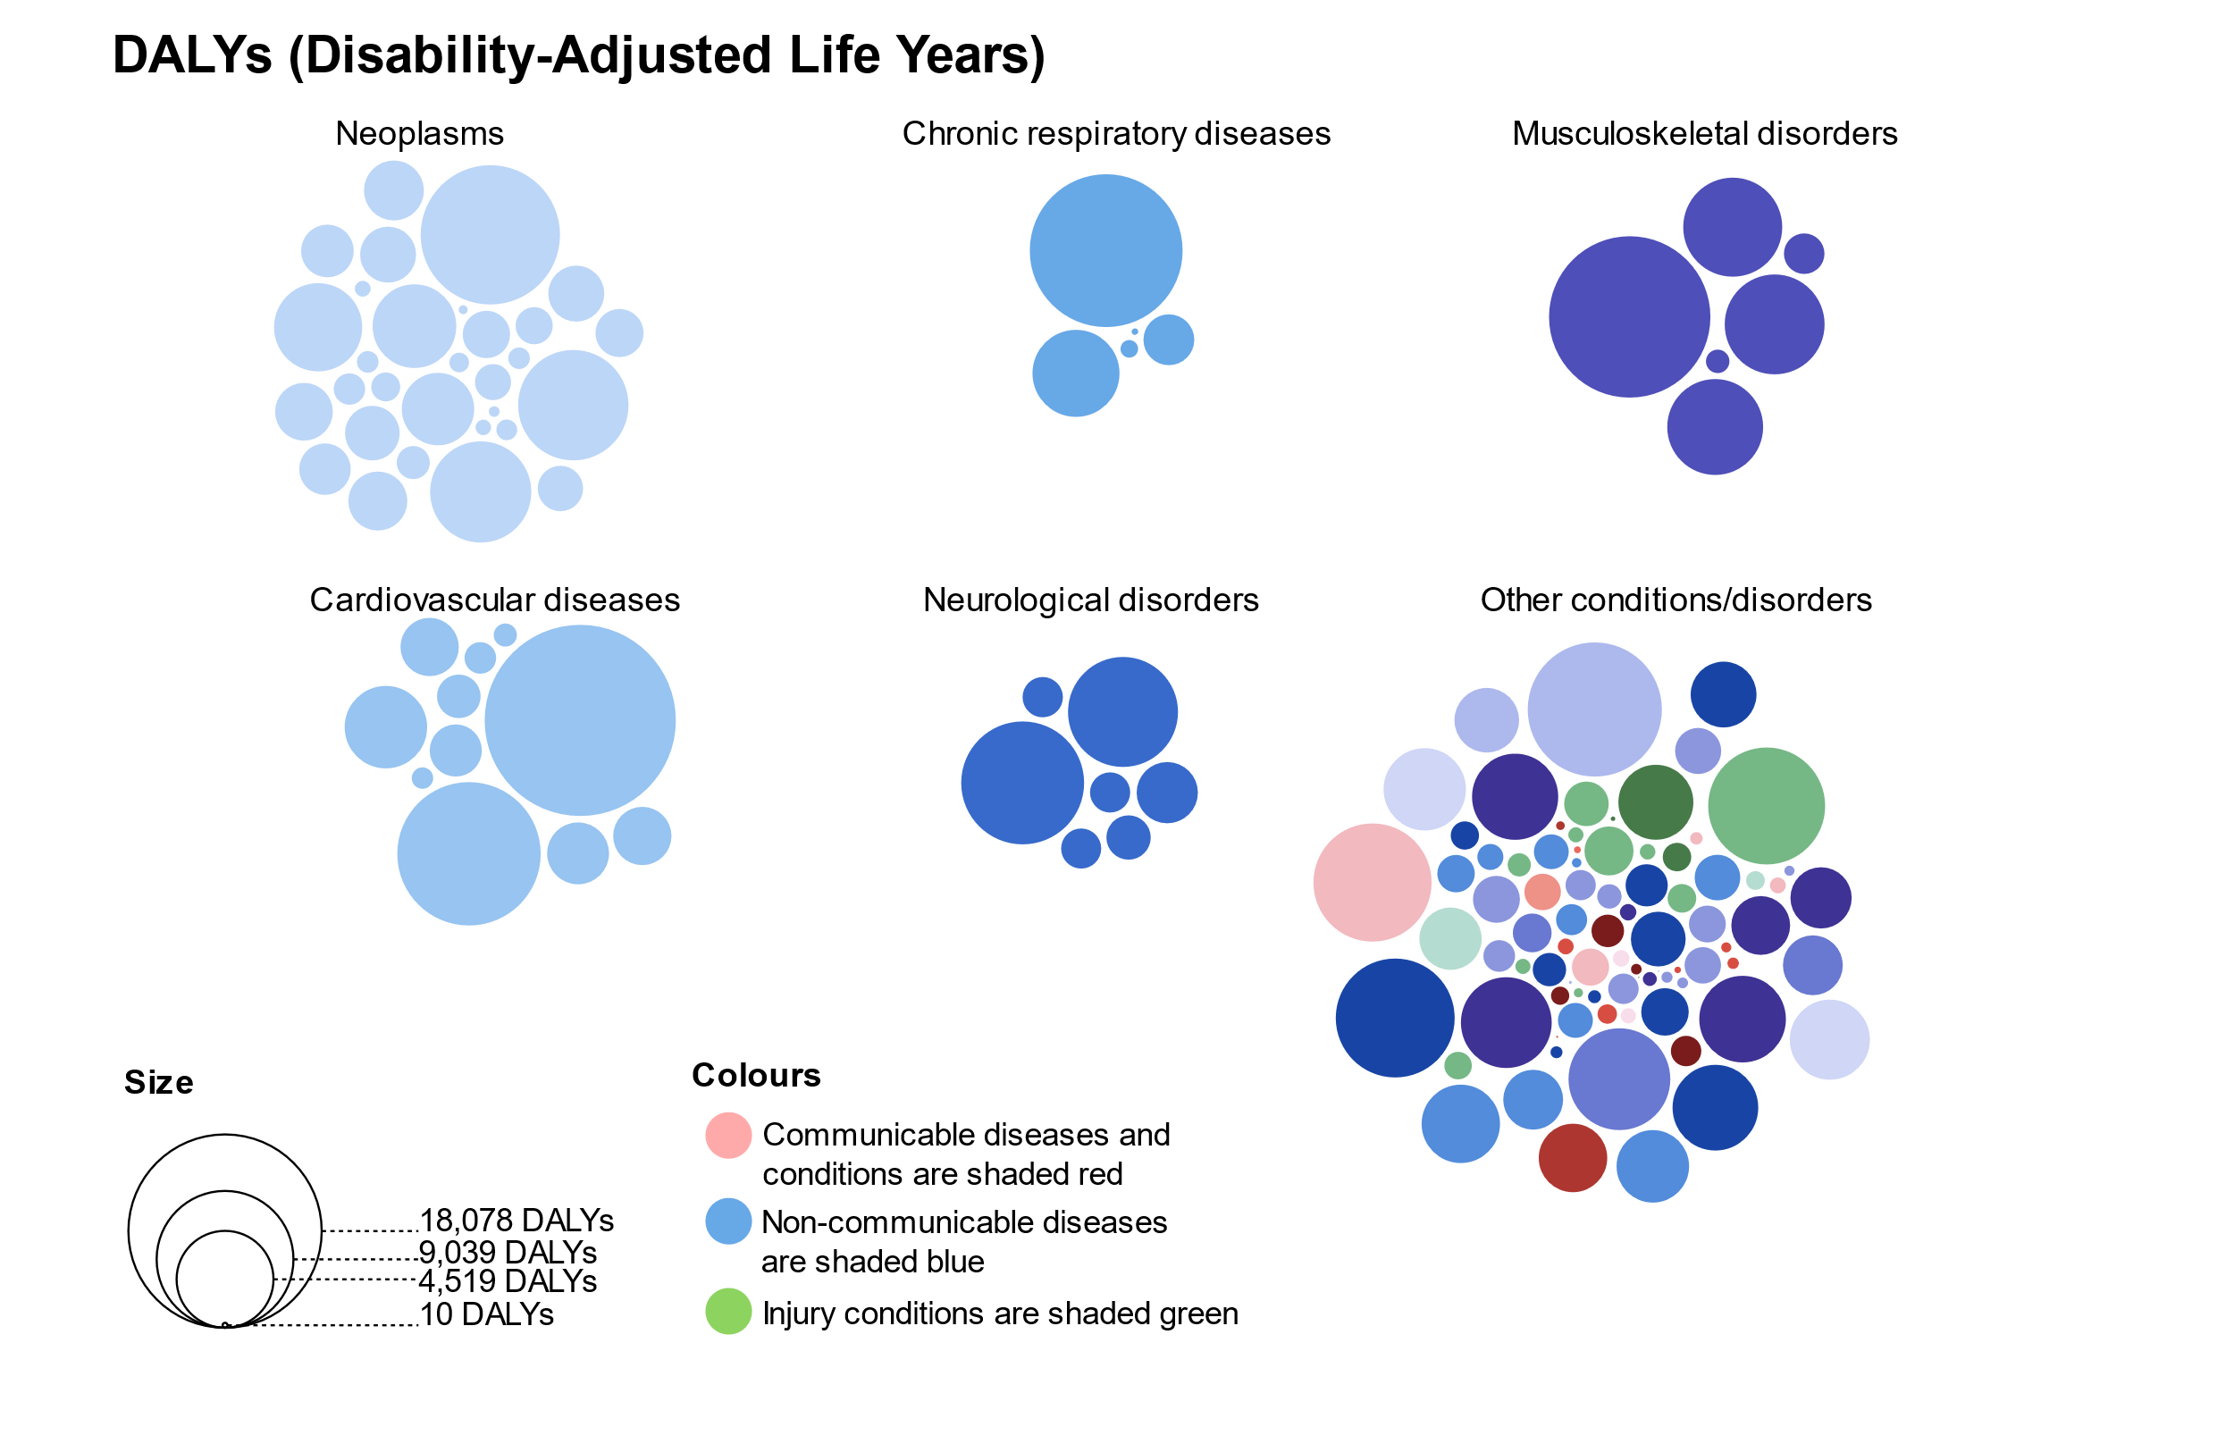

Figure 5.4. Estimated number of disability adjusted life years lost in West Sussex; 2019

## Has the burden of disease changed over time?

In this section we compare the picture of burden from level two cause groups between 2009 and 2019. We show the percentage change in the death rate and DALY rate in figures 6.1. and 6.2. respectively. To see more detail, and to find the YLL and YLD estimates change see the interactive site: <https://wsx-gbd-2019.netlify.app/>

Figure 6.1. shows that in the 10 years to 2019, the rate of deaths for most communicable and maternal diseases decreased whilst neoplasms, chronic respiratory and other long term non-communicable causes of death increased along with accidental injuries. The rate of deaths caused by transport injuries fell by 17% to 4.5 deaths per 100,000 population.

The biggest increase in death rate was for diabetes and kidney diseases which increased by 15.5% to 22.8 deaths per 100,000 population. The biggest decline in rate of death was for enteric infections which halved over 10 years.

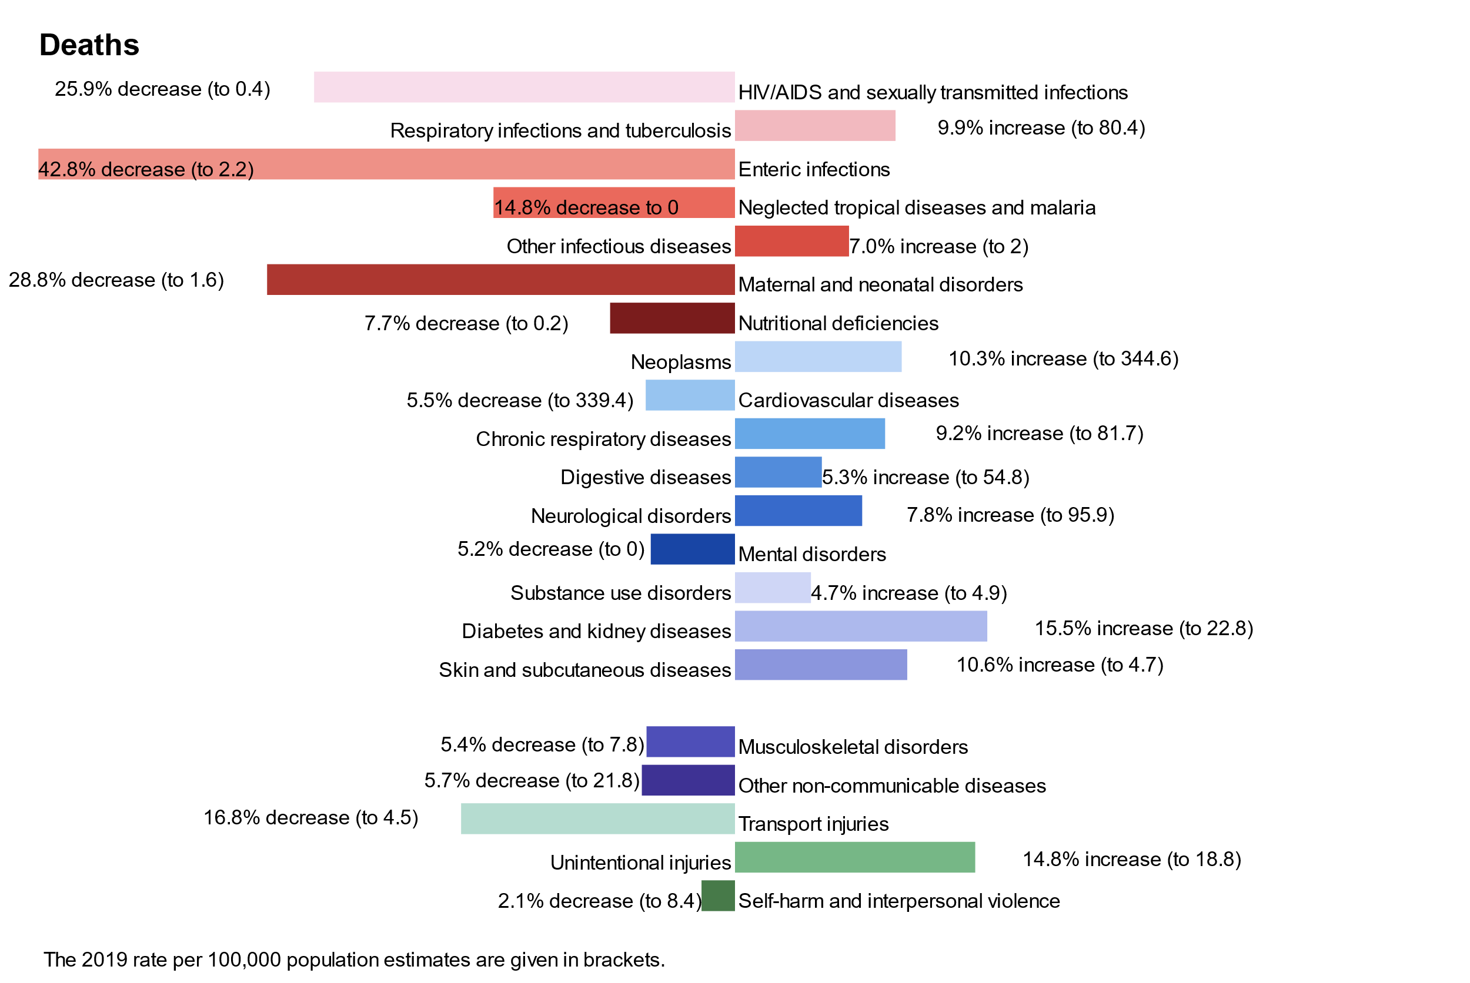

Figure 6.1. Change in rate of deaths between 2009 and 2019; level two causes; West Sussex; all ages

It should be reiterated that this iteration of the global burden of disease is for the period up to 2019, which is before the global COVID-19 pandemic which will inevitably alter the trends in ill health and mortality in years to come.

The next figure shows the 10-year change for the combined measure of disability adjusted life years lost.

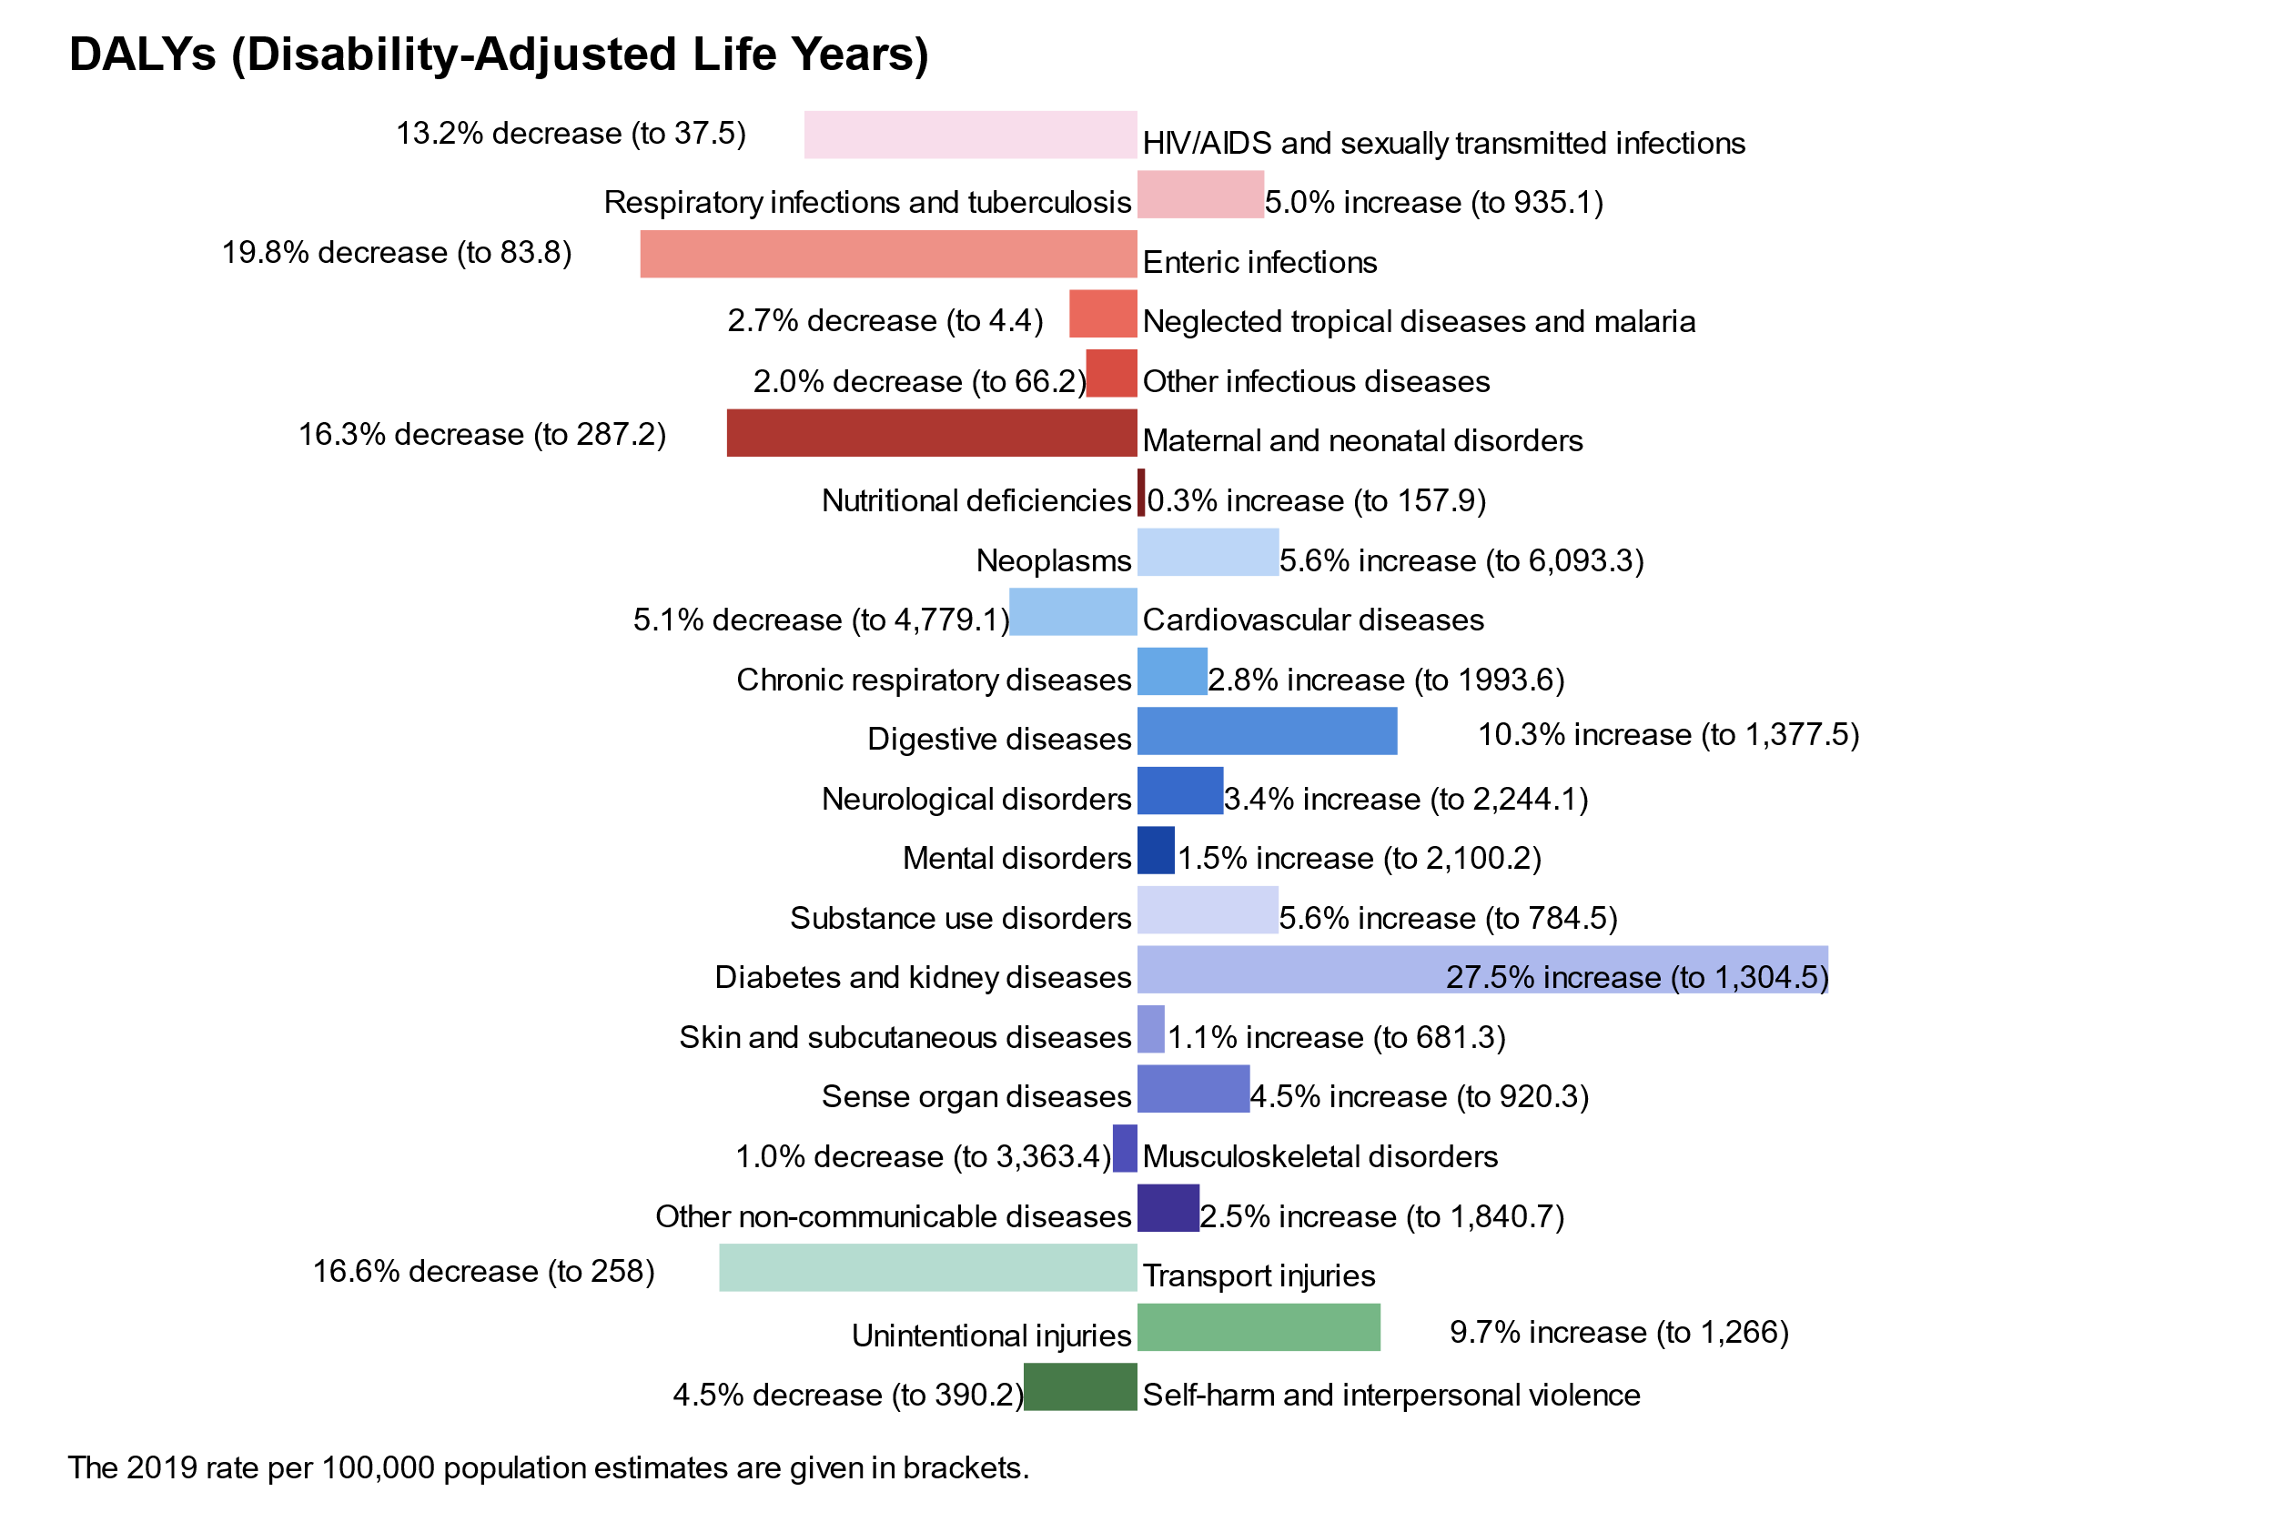

Figure 6.2. Change in rate of disability-adjusted years lost between 2009 and 2019; level two causes; West Sussex; all ages

To account for differences in population size and demographics, the remaining analyses use standardised estimates which detail the number (e.g. deaths) per 100,000 population. More information on standardising rates is given in the box below. Note that this is not adjusted for age, although the final section shows the impact of controlling for age on estimating and comparing estimates of ill health and death across areas.

Looking at crude estimates helps to know what the true impact might be for our area (e.g. to anticipate the number of patients a service might need to cater for, the number of cases) and this can help to plan services.

You could compare these crude estimates with those in other areas, or over time, to see if things are better in some areas or are improving over time, although any differences (or similarities) in estimates could be at least in part due the underlying differences in populations (e.g. areas with fewer or greater numbers of older people, or the sheer size of the population).

As an example, area A may have recorded 2,000 deaths and area B recorded 1,500 deaths. You might think that area A has a much bigger issue of mortality than area B. However, if area A has a population of 500,000, the rate of deaths would be 400 deaths per 100,000 population. If area B has a population of 300,000, then the rate of deaths is higher in area B (500 per 100,000 population).

## How does West Sussex compare over time to the South East region and England?

In this final section we explore how the deaths and other measures of burden in West Sussex compare to national estimates. The figures show the last ten years of estimated rates per 100,000 for West Sussex for each of the level two burden cause groups with the colour of the dot representing whether the rate was significantly higher, lower, or similar to the rate for either the region or nationally.

In this print report we should deaths and DALYs. However, as with the other sections, you can view the interactive figure on the <https://wsx-gbd-2019.netlify.app/> where you can also toggle each of the measures of burden from deaths, to DALYs for any of the level two causes and you can switch between all ages and age-standardised rates as well as choose to compare West Sussex rate estimates with either South East region or England overall.

Looking at all cause deaths, in West Sussex, they are consistently significantly higher when looking at the all-age rate compared to England (figure 7.1.) and South East region (see interactive tool).

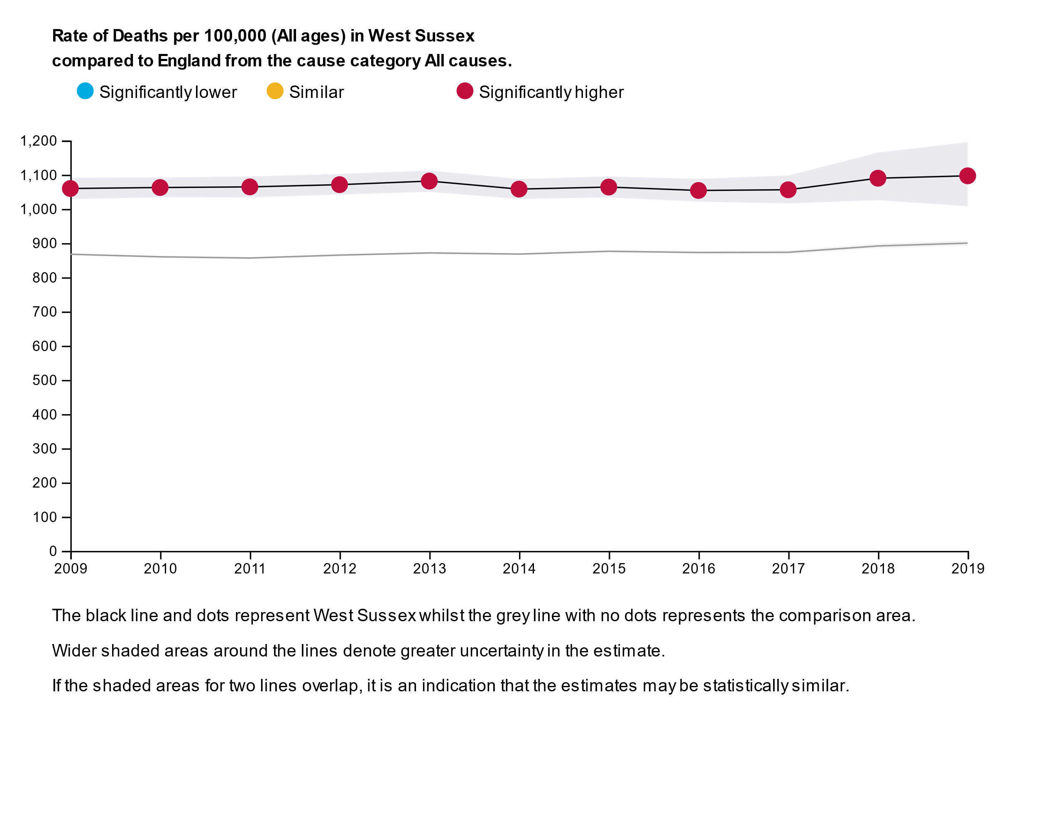

Figure 7.1. Rate of deaths (all cause) per 100,000 population (all ages); West Sussex compared to England; 2009-2019

There are two things you can tell from these figures, how has West Sussex changed over time and at each time point how does it compare with another area (South East England or England overall).

Over the 10 year period, West Sussex crude rate has been largely the same. In 2009 it was 1,060 deaths per 100,000 (95% confidence interval, 1,029-1,091 per 100,000) and in 2019 it was 1,097 deaths (95% confidence interval, 1,008-1,195). Whilst the rate has increased over the 10 years, the increased uncertainty in recent year (denoted by the wider 95% confidence interval) means that the rate has not increased statistically significantly.

At first glance, West Sussex consistently has around 200 more deaths (per 100,000) per year compared with England overall and the margin of error. However, when the estimates are age standardised (see figure 7.2.), the comparison is very different, with West Sussex age standardised deaths significantly lower compared to national rates.

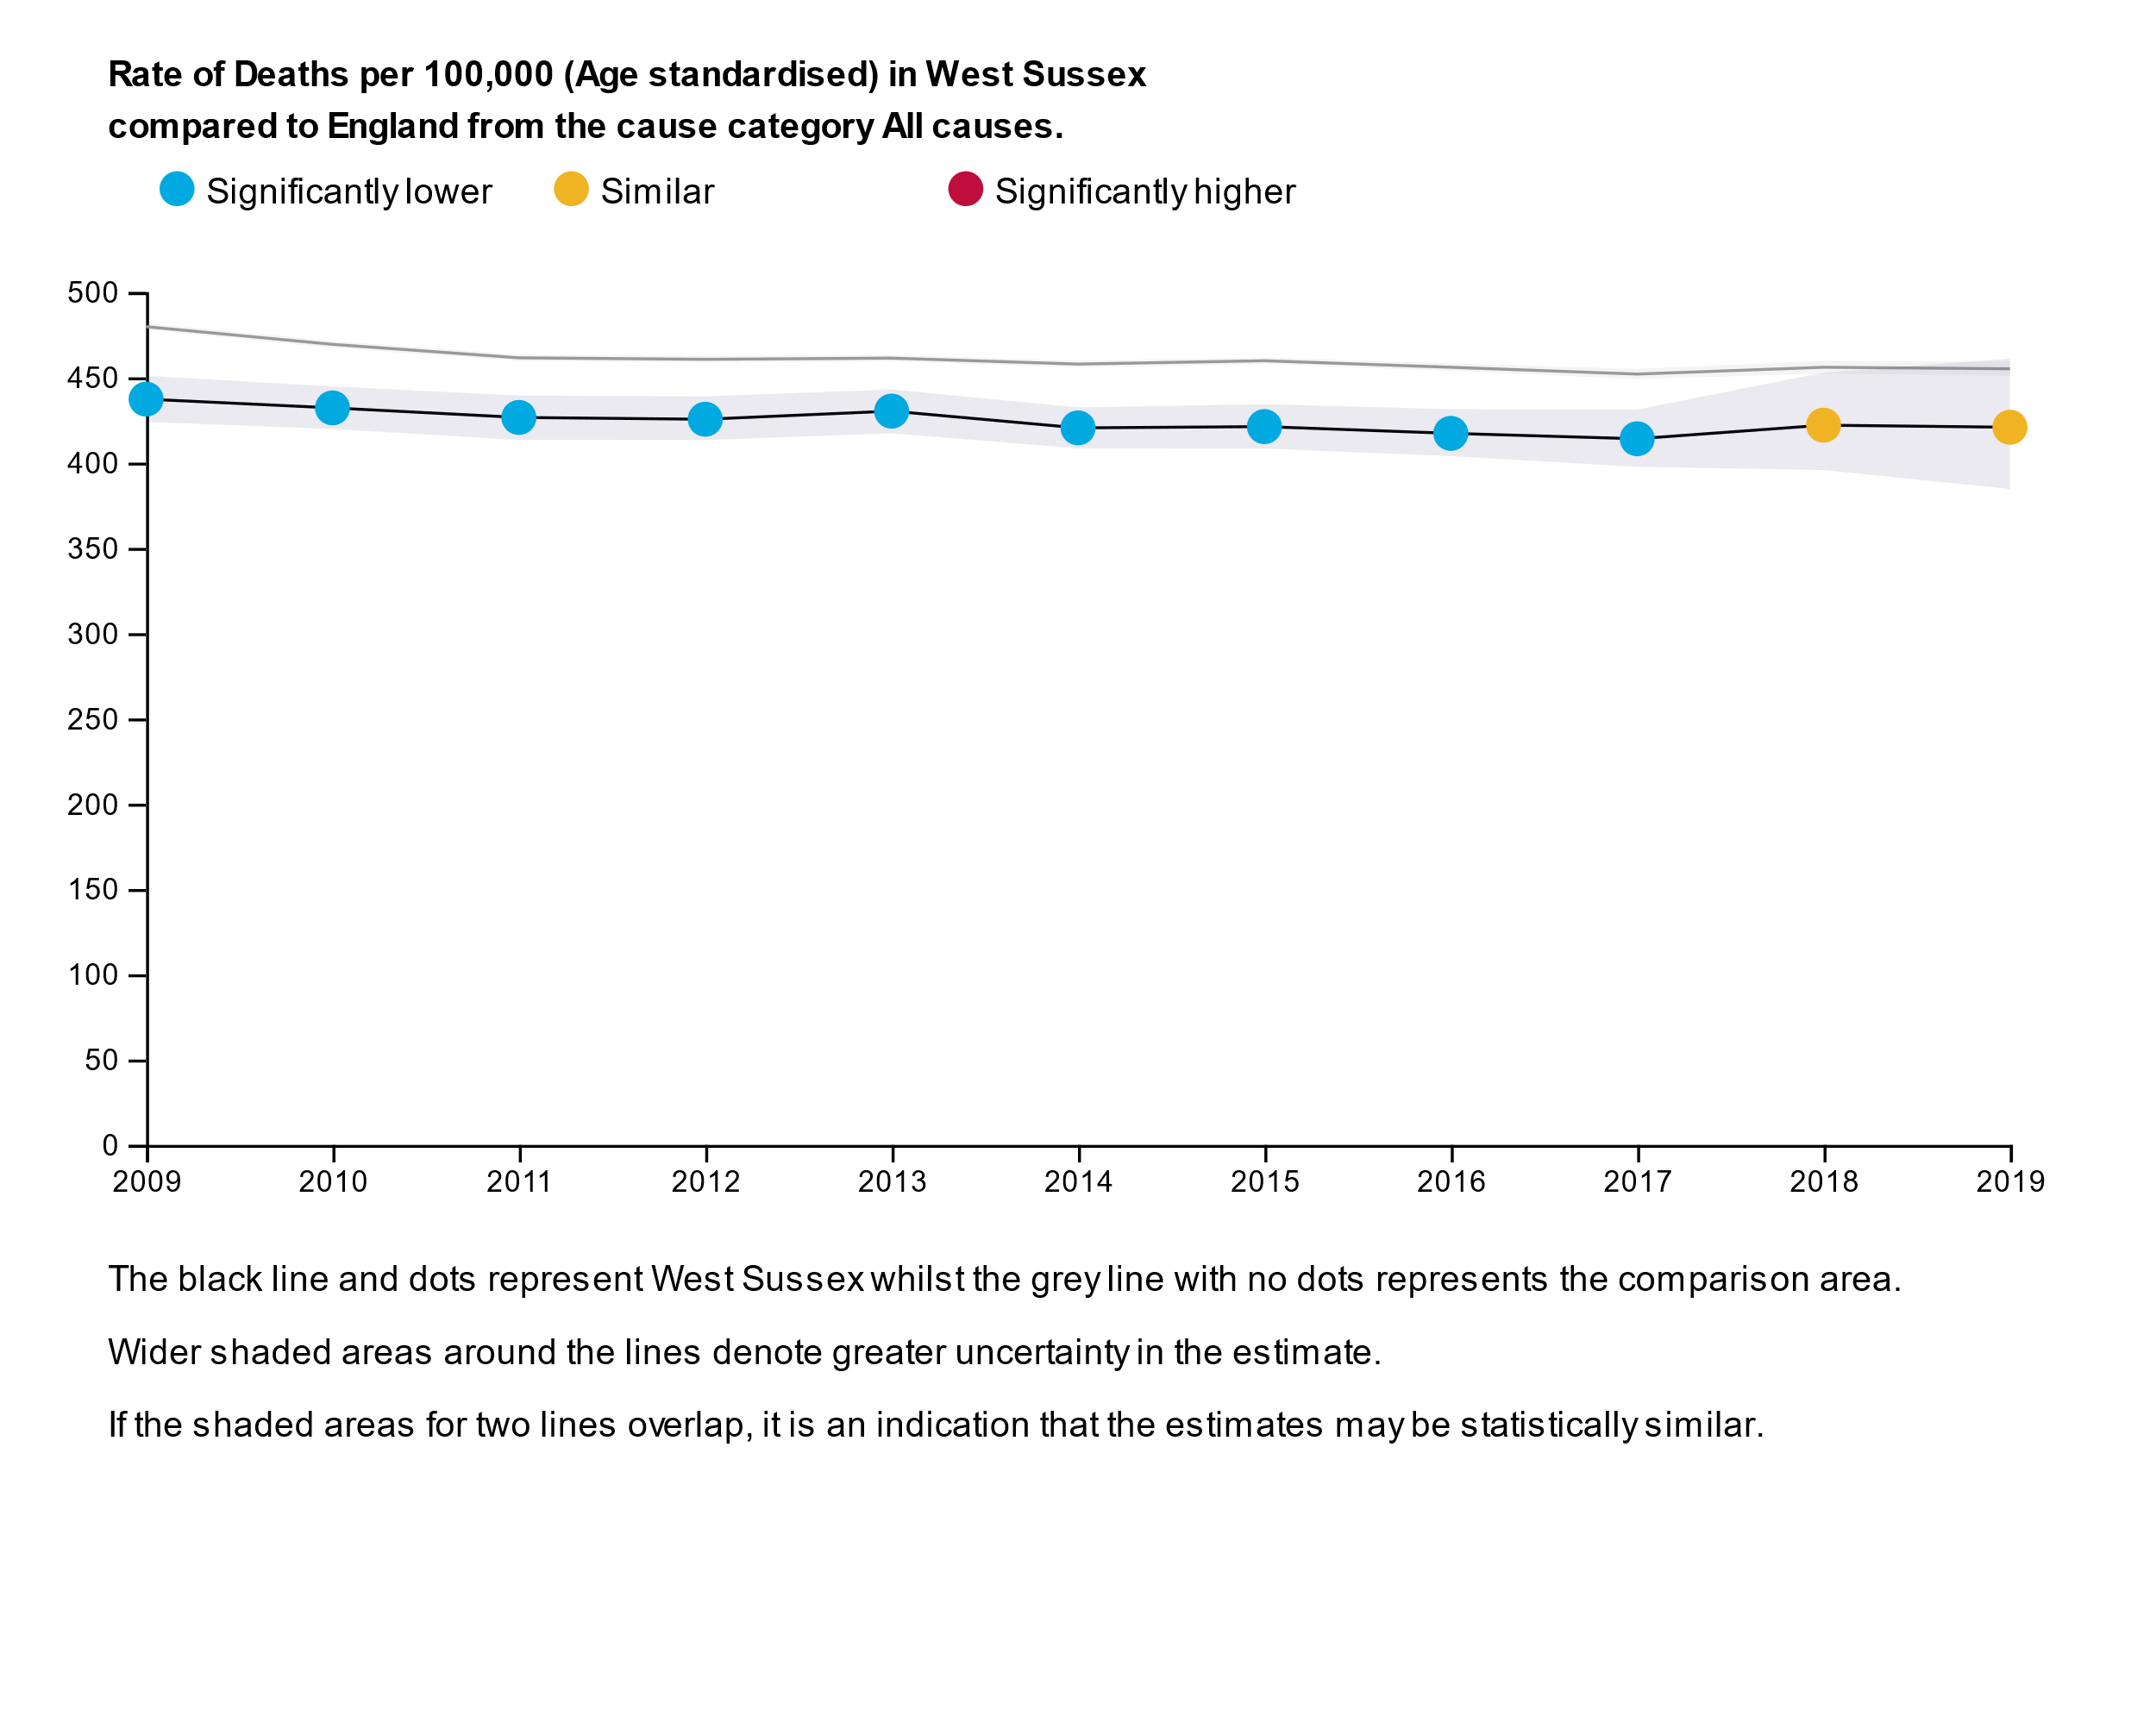

Figure 7.2. Rate of deaths (all cause) per 100,000 population (age standardised); West Sussex compared to England; 2009-2019

Age standardising not only controls for the number of people in an area but also the age structure of a population. As some conditions and outcomes are more likely among older age groups, you might expect to find the burden of disease higher in West Sussex as it has a relatively older age structure compared to the South East and England overall. Age standardising helps to remove the potential confounding effect that age has.

Age standardising has a big impact on measuring all cause deaths, taking West Sussex from significantly higher deaths compared to England to having significantly lower deaths as an age standardised rate.

Another example is deaths caused by neoplasms (cancer) which have been estimated in the global burden of disease to be consistently significantly higher than in England overall, but this difference disappears when you look at age standardised differences.

The final figure in this report shows the

Small multiples of DALYs 22 conditions? In R, that might show the trend you talk about in the summary.

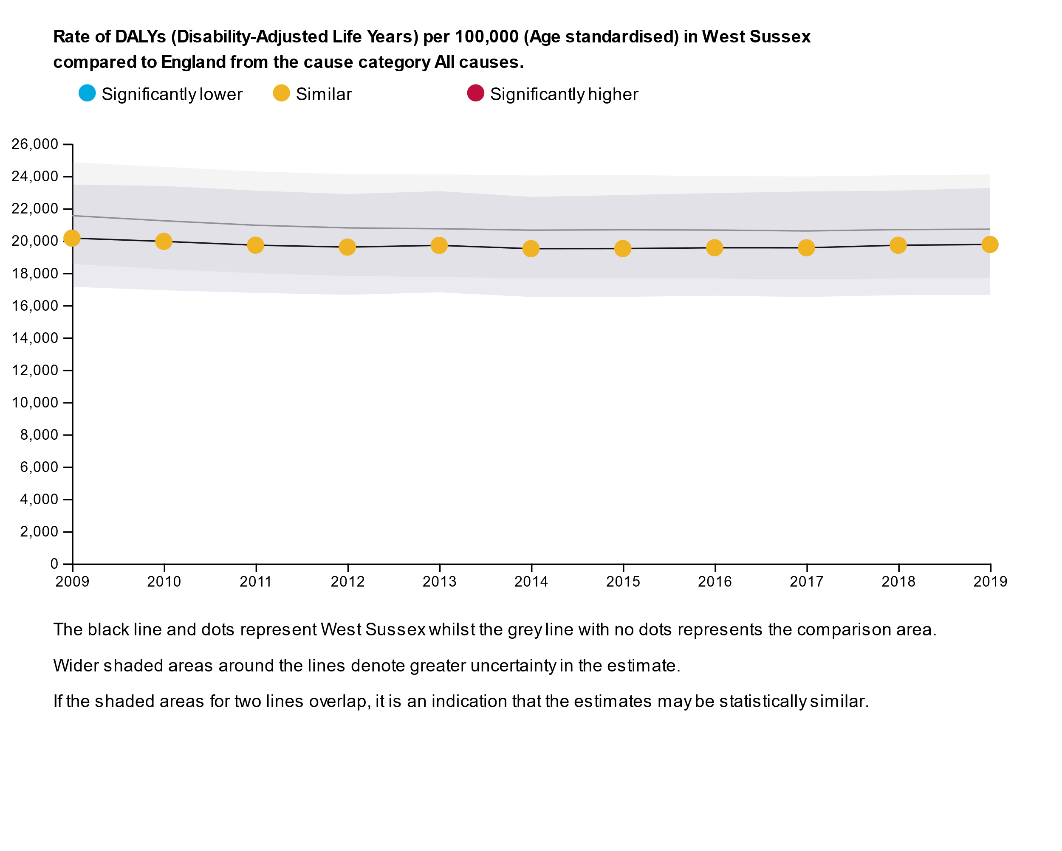

Figure 7.3. Rate of disability adjusted life years lost (all cause) per 100,000 population (age standardised); West Sussex compared to England; 2009-2019

In summary, over the last 10 years, West Sussex estimated burden has followed the trend similar to that of regional and national estimates, particularly when estimates take into account the different age profile/structure of the county and other areas.